PROJECT-5

AWS RESOURCES CREATION USING ANSIBLE

### ****What is Ansible?****

Ansible is an open-source automation tool used for configuration management, application deployment, orchestration, and task automation. It simplifies IT processes by enabling users to automate repetitive tasks and manage systems efficiently. Ansible is agentless, which means it does not require any software or agents to be installed on the target systems. Instead, it uses SSH (or WinRM for Windows) to communicate with them

### ****How Ansible Helps:****

1. **Automation**: Automates repetitive IT tasks such as software installations, updates, and system configurations.
2. **Consistency**: Ensures consistent configuration and deployment across multiple systems, reducing human errors.
3. **Scalability**: Manages a large number of servers and devices easily with a single playbook.
4. **Orchestration**: Coordinates complex workflows, such as deploying applications or managing multi-tier environments.
5. **Cost Efficiency**: Reduces operational costs by saving time and effort in system management.
6. **DevOps Enablement**: Enhances DevOps workflows by integrating seamlessly with CI/CD pipelines, version control systems, and container orchestration platforms.

### ****Key Features of Ansible:****

**Agentless Architecture:**

* 1. No need for additional software or agents on managed nodes.
  2. Communication happens via SSH

**Simple YAML Syntax**:

* 1. Uses human-readable YAML files called **playbooks** to define automation tasks.

**Idempotency**:

* 1. Ensures that tasks produce the same results regardless of how many times they are executed.

**Modular Design**:

* 1. Comes with built-in modules for various tasks, such as managing files, users, services, and networks

**Platform Independent**:

* 1. Supports managing Linux, Windows, cloud platforms (AWS, Azure, GCP), containers, and network devices.

**Integration with DevOps Tools**:

* 1. Works seamlessly with Jenkins, Docker, Kubernetes, Terraform, and Git.

**Inventory Management**:

* 1. Maintains a list of systems to be managed using an inventory file (INI or YAML format).

**Dynamic Inventory Support**:

* 1. Automatically updates the inventory file based on external sources like AWS, Azure, or GCP.

**Security**:

* 1. Ansible Vault encrypts sensitive data such as passwords, API keys, and other credentials.

**Scalability**:

* 1. Efficiently manages hundreds or thousands of systems at scale.

**Extendability**:

* 1. Custom modules and plugins can be developed to suit specific needs.

**Community Support**:

* 1. Backed by a large, active community providing regular updates, modules, and plugins.

### ****Common Use Cases of Ansible****:

* Automating server provisioning.
* Managing configuration files across environments.
* Deploying applications and services.
* Setting up cloud infrastructure (e.g., AWS EC2, S3, VPC).
* Orchestrating containers and Kubernetes clusters.
* Conducting system updates and patch management.
* Configuring and managing network devices.

An **Ansible playbook** is a structured YAML file used in the **Ansible automation tool** to define configurations, deployments, and orchestration processes for IT infrastructure and applications. It allows users to automate tasks across multiple systems in a simple, reusable, and human-readable format.

### ****Key Characteristics of an Ansible Playbook****

1. **YAML Format**: Written in YAML, which is easy to read and write.
2. **Declarative Syntax**: Describes what you want to happen rather than how to do it.
3. **Idempotency**: Ensures tasks produce the same result even if executed multiple times.
4. **Modularity**: Supports breaking automation into reusable roles and tasks.
5. **Human-Readable**: Easy for both technical and non-technical users to understand.

### ****Key Components****

**Hosts**:

* 1. Specifies which systems to target.
  2. Can be a single host, a group, or localhost.

**Tasks**:

* 1. Define the individual operations to perform (e.g., install packages, copy files).
  2. Use **Ansible modules** to accomplish specific tasks (e.g., yum, copy, service).

**Modules**:

* 1. Predefined tools (e.g., ansible.builtin.yum, ansible.builtin.copy) to perform tasks.
  2. Extensible to custom modules.

**Variables**:

* 1. Allow customization and dynamic values.
  2. Defined directly in the playbook, inventory, or external files.

**Handlers**:

* 1. Special tasks triggered only when notified (e.g., restarting a service after a configuration change).

**Roles**:

* 1. A method to organize playbooks into reusable components.

### ****Why Use Ansible Playbooks?****

* **Automation**: Simplifies repetitive tasks like software installation, updates, and configuration.
* **Consistency**: Ensures the same steps are applied across all systems.
* **Scalability**: Easily handles hundreds or thousands of machines.
* **Version Control**: Can be stored and tracked in Git repositories.

### ****Step 1: Prepare Your AWS Account****

1. **Create an IAM User**
   1. Log in to the AWS Management Console.
   2. Navigate to **IAM > Users > Add user**.
   3. Add a username and select **Programmatic access**.
   4. Attach the **AdministratorAccess** policy for simplicity (you can restrict permissions later).
   5. Download the **Access Key ID** and **Secret Access Key** for the IAM user.

**Method-1**:**AWS Infrastructure Provisioning with Ansible playbook script using inline variables.**

**-create one ec2-instance**

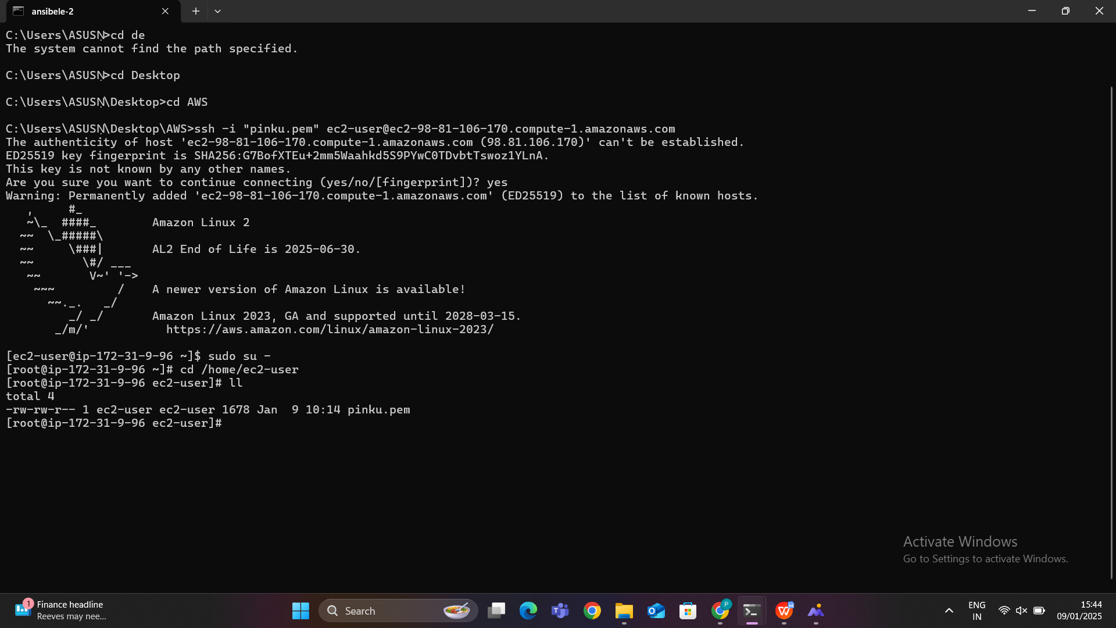

Move to the path of our pem file their type this command :

scp -i pinku.pem pinku.pem ec2-user@publicip:/home/ec2-user

**Explanation:**

scp

* 1. Stands for **Secure Copy Protocol**.
  2. It is used to securely transfer files between a local machine and a remote machine over SSH.

-i pinku.pem

* 1. Specifies the private key file (pinku.pem) to use for authentication.
  2. This private key corresponds to the key pair you used when creating the EC2 instance.
  3. It ensures secure access to the EC2 instance.

pinku.pem

* 1. This is the **source file** you want to copy.
  2. In this case, the file being copied is the pinku.pem key itself.

ec2-user

* 1. The **username** for logging into the remote EC2 instance.
  2. For Amazon Linux and some Ubuntu AMIs, ec2-user is the default username.
  3. For other AMIs, it may differ (e.g., ubuntu for Ubuntu instances).

@publicip

* 1. The **public IP address** of the EC2 instance.
  2. Replace publicip with the actual IP address of your EC2 instance.

:/home/ec2-user

* 1. The **destination path** on the EC2 instance where the file will be copied.
  2. In this case, the file will be copied to the /home/ec2-user directory of the EC2 instance.

### ****What Happens When You Run This Command?****

1. The scp command connects to the remote EC2 instance using the private key specified by -i pinku.pem.
2. It securely transfers the pinku.pem file from your local machine to the /home/ec2-user directory on the remote EC2 instance.

### ****Key Considerations****

**Ensure the Security of** pinku.pem

* 1. The .pem file is sensitive and provides access to your EC2 instance.
  2. chmod 600 pinku.pem

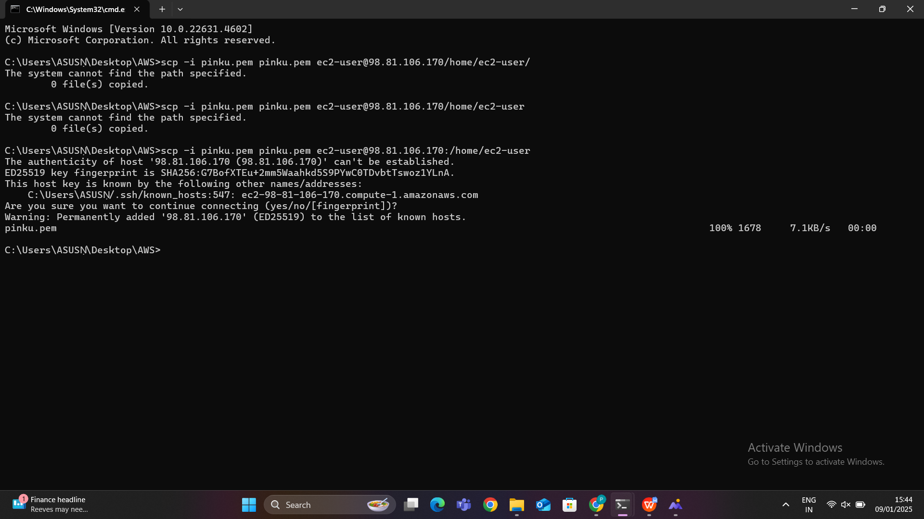

Now go to the terminal move to the path :cd /home/ec2-user : there we see our pem file

### Give permission to that pem file : sudo chmod 600 pinku.pem

### sudo chmod 600 pinku.pem

* **Purpose**: Sets the file permissions for the pinku.pem file to 600.
* **Details**:
  + chmod: Command to change file permissions.
  + 600: Grants read and write permissions to the file's owner, but no permissions to group members or others.
  + **Use case**: Ensures that the private key file (pinku.pem) is secure and only the owner can use it. This is required when using SSH to connect to an EC2 instance, as insecure key permissions will result in errors.

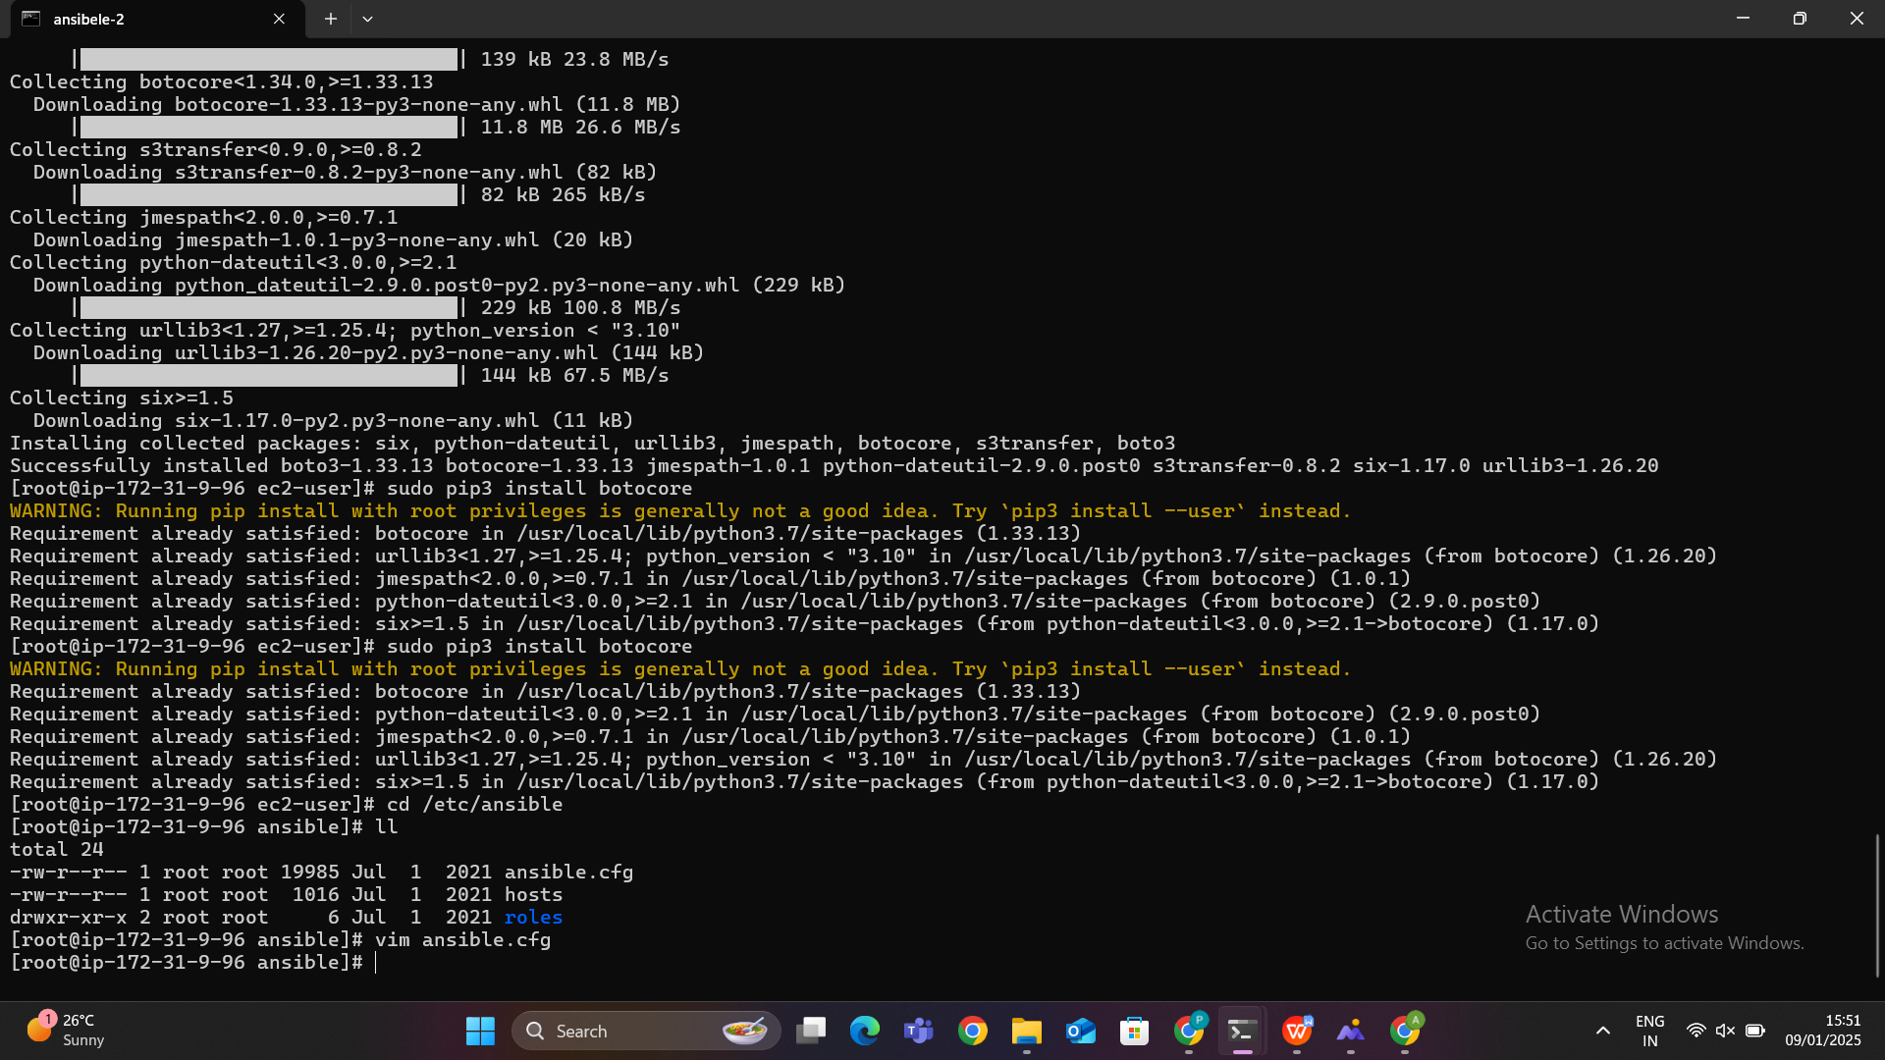

**Install ansible :**

### sudo amazon-linux-extras install ansible2 -y

* **Purpose**: Installs Ansible version 2 on an Amazon Linux instance using the amazon-linux-extras repository.
* **Details**:
  + amazon-linux-extras: A package manager on Amazon Linux that provides access to additional software packages.
  + ansible2: Specifies that Ansible version 2 should be installed.
  + -y: Automatically confirms the installation without prompting the user.

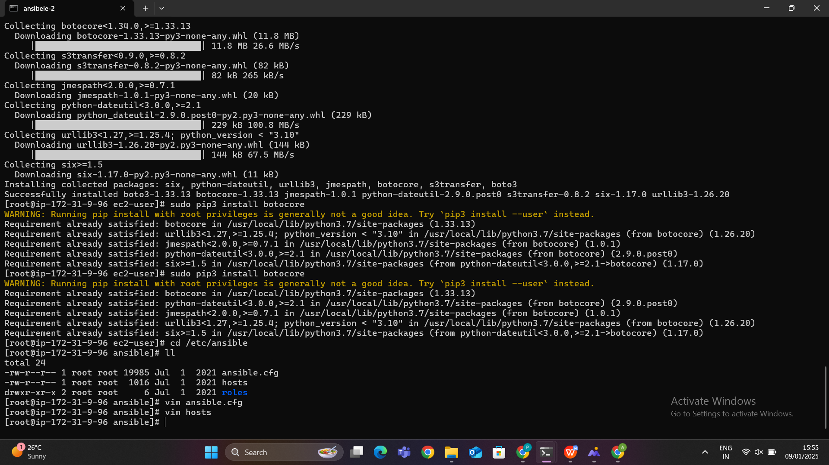

### 4. sudo pip3 install boto3

* **Purpose**: Installs the **boto3** library for Python 3.
* **Details**:
  + pip3: Package manager for Python 3.
  + install boto3: Downloads and installs the boto3 library.
  + **Boto3**: The official Python SDK for AWS. It allows Python scripts to interact with AWS services like S3, EC2, DynamoDB, and more.
  + **Use case**: Essential for automating AWS-related tasks using Python

### 5. sudo pip3 install botocore

* **Purpose**: Installs the **botocore** library for Python 3.
* **Details**:
  + **Botocore**: A low-level core library used by boto3. It handles the underlying logic for AWS service interactions, including HTTP requests and responses.
  + **Dependency**: Botocore is a dependency of boto3, so it might already be installed when you install boto3. This command ensures it is up-to-date.

### 6. sudo pip3 install boto

* **Purpose**: Installs the older version of the AWS SDK for Python, **boto**.
* **Details**:
  + boto: Predecessor to boto3. It provides similar functionality but lacks support for newer AWS services and features.
  + **Why it might be used**: Some legacy applications or scripts might still rely on boto instead of boto3.
  + **Recommendation**: Use boto3 for modern projects, as boto is no longer actively maintained.

Now go to the cd /etc/ansible path go inside host using vim host then remove # near host_key_checking=False

### ****Step 1: Change Directory****

**Command**: cd /etc/ansible

* **Purpose**: Navigates to the directory where Ansible's configuration files, including the inventory (hosts) file, are located.
* **Details**:
  + /etc/ansible: Default directory for Ansible configuration files on most Linux systems.

### ****Step 2: Open**** hosts ****File****

**Command**: vim hosts

* **Purpose**: Opens the hosts file using the vim text editor.
* **Details**:
  + The hosts file in Ansible is used to define the inventory, which lists all the managed nodes (remote machines) that Ansible will work with.

### ****Step 3: Modify the**** host_key_checking ****Setting****

**Instruction**: Remove the # from #host_key_checking = False.

* **Purpose**: Disables **host key checking** during SSH connections.
* **Details**:
  + host_key_checking = False: Prevents Ansible from verifying the SSH host key of the remote machine.
  + When set to **True** (default behavior):
    - Ansible checks the remote host's SSH key against the known_hosts file.
    - If the host's key has changed or is not in the file, Ansible throws an error and does not proceed.
  + By setting it to **False**, you bypass this check, allowing Ansible to connect to remote machines without interruption.
* **Why Remove the** #**?**:
  + The # indicates that the line is commented out and is not active.
  + Removing it activates the host_key_checking = False configuration.

### ****Why Disable Host Key Checking?****

**Simplifies Automation**:

* 1. Avoids SSH key mismatch issues when connecting to new or re-deployed servers.
  2. Useful in dynamic or cloud environments where hosts frequently change.

**Speeds Up Deployment**:

* 1. No need for manual intervention to accept SSH host keys.

**Temporary Debugging**:

* 1. Useful when you are troubleshooting Ansible playbooks or SSH connection issues.

### ****Potential Risks of Disabling Host Key Checking****

**Security Concerns**:

* 1. Disabling host key checking makes your connection vulnerable to **Man-in-the-Middle (MITM)** attacks, where an attacker could impersonate the remote host.

**Not Recommended in Production**:

* 1. It's better to manage host keys properly using tools like ssh-keyscan or ensuring known_hosts entries are accurate.

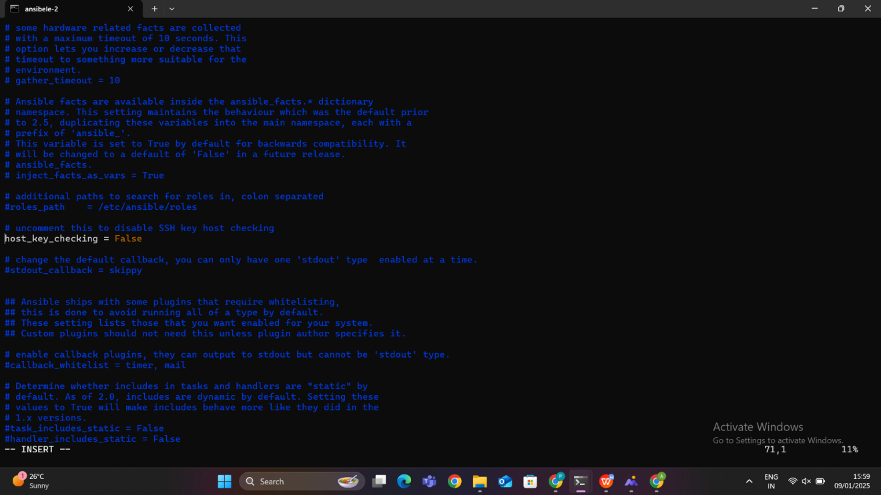

### ****Step 1: Navigate to the Inventory File****

* The inventory file in Ansible is used to list the hosts (managed nodes) that Ansible will control.
* By default, this file is located at /etc/ansible/hosts.

### ****Step 2: Open the File****

### Use the vi or vim command to open an

d \\edit the file

vi /etc/ansible/hosts

### ****Step 3: Add the Details****

[localhost]

127.0.0.1 ansible_host=private-ip-address ansible_python_interpreter=/usr/bin/python3 ansible_user=ec2-user ansible_ssh_private_key_file=/home/ec2-user/pinku.pem

### ****Explanation of Each Component****

#### [localhost]

* This defines a group of hosts named localhost.
* In Ansible, hosts are grouped under brackets [group_name]. This helps organize and target multiple hosts at once during playbook execution.

#### 127.0.0.1

* This specifies the IP address of the local machine (localhost).
* Here, it is mapped to the actual host IP (given as 172.31.81.111) using the ansible_host variable.

#### ansible_host=172.31.81.111

* This tells Ansible that the actual IP address to connect to is 172.31.81.111, even though the host is referred to as 127.0.0.1.
* This is useful in cases where the inventory hostname doesn’t match the actual IP of the machine.

#### ansible_python_interpreter=/usr/bin/python3

* Specifies the path to the Python interpreter on the managed node.
* Ensures Ansible uses Python 3 instead of the default Python version (often Python 2 on older systems).

#### ansible_user=ec2-user

* Defines the SSH user that Ansible should use to connect to the host.
* For AWS EC2 instances, the default user is often ec2-user (depending on the AMI used).

#### ansible_ssh_private_key_file=/home/ec2-user/new-key.pem

* Specifies the path to the private SSH key file that Ansible will use to authenticate the connection.
* **Important**: The private key file must have the correct permissions (chmod 600).

### ****Why Are These Details Added?****

**Specify the Target Host**:

* + Ansible needs to know which hosts to connect to, and these details provide the necessary connection information.

**Configure SSH Access**:

* + Ansible uses SSH to manage remote hosts. The ansible_user and ansible_ssh_private_key_file settings ensure that Ansible can log in to the host without manual intervention.

**Python Path**:

* + Many Ansible modules require Python. The ansible_python_interpreter ensures Ansible uses the correct Python version on the managed node.

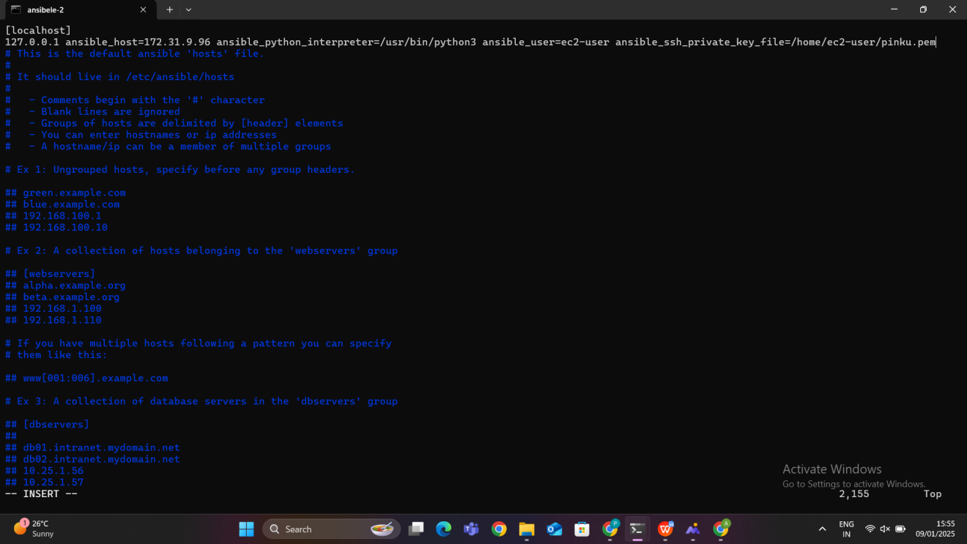

### In Ansible, the **inventory file** is where you define the list of hosts (managed nodes) that Ansible interacts with. To ensure proper permissions or configurations for the inventory file, you may need to uncomment certain lines in Ansible’s configuration file (ansible.cfg). Here's the theoretical explanation:

### ****1. Understanding the Inventory File****

* The inventory file is typically located at /etc/ansible/hosts by default.
* It contains the IP addresses or hostnames of the systems that Ansible manages.

### ****2. Role of**** ansible.cfg ****File****

* The ansible.cfg file is the main configuration file for Ansible.
* It allows you to specify settings like the location of the inventory file, logging, retries, and more.
* By default, this file contains many commented-out settings, indicated by the # symbol. These settings are inactive until uncommented.

### ****3. Configuring Inventory Permissions in**** ansible.cfg

* In the [defaults] section of the ansible.cfg file, you can define the path to your inventory file.

#inventory = /etc/ansible/hosts:The # indicates that this line is commented out and not active.

Remove the # to enable this setting:

### ****Why Remove the**** #****?****

* Uncommenting the line ensures that Ansible uses the specified inventory file (/etc/ansible/hosts).
* If the line remains commented out, Ansible uses its default configuration, which may not match your intended setup.

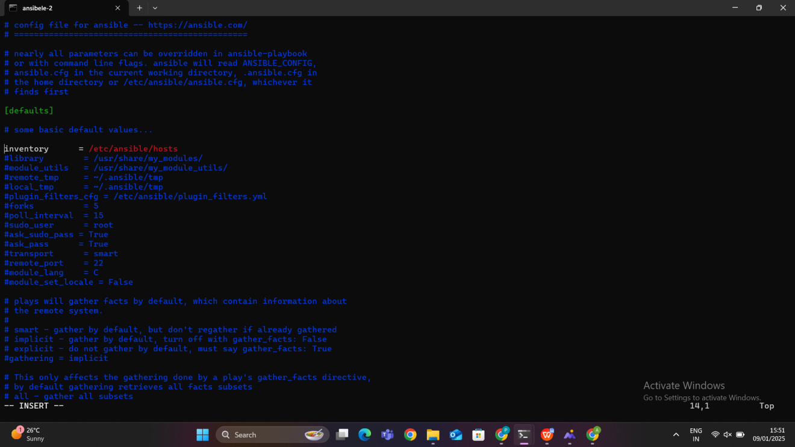

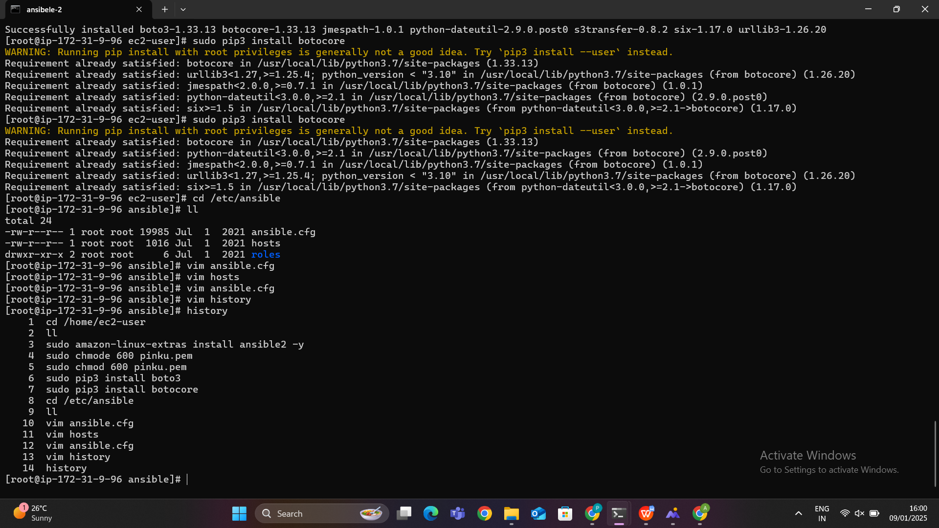

Ansible uses the state parameter to define the desired status of resources. The state tells Ansible whether to create, update, delete, or leave a resource unchanged. Below is a list of common Ansible states and their explanations:

### ****1.**** present

* **Purpose**: Ensures that a resource exists.
* **Behavior**:
  + If the resource does not exist, Ansible creates it.
  + If the resource already exists, no changes are made unless additional parameters in the playbook differ from the current configuration.
* **Use case**:
  + Creating new resources like EC2 instances, VPCs, or security groups.
  + Ensuring a file exists on a server.

### ****2.**** absent

* **Purpose**: Ensures that a resource is deleted.
* **Behavior**:
  + If the resource exists, Ansible removes it.
  + If the resource does not exist, no action is taken.
* **Use case**:
  + Deleting AWS resources (e.g., EC2, subnets, or route tables).
  + Removing unnecessary files or packages from a server.

### ****3.**** started

* **Purpose**: Ensures a service is running.
* **Behavior**:
  + If the service is not running, Ansible starts it.
  + If the service is already running, no changes are made.
* **Use case**:
  + Managing services like nginx, httpd, or docker on a server.

### ****4.**** stopped

* **Purpose**: Ensures a service is stopped.
* **Behavior**:
  + If the service is running, Ansible stops it.
  + If the service is already stopped, no changes are made.
* **Use case**:
  + Stopping unnecessary services on a server.

### ****5.**** restarted

* **Purpose**: Ensures a service is restarted.
* **Behavior**:
  + Stops the service if running, and then starts it again.
* **Use case**:
  + Applying configuration changes to a service that requires a restart.

### ****6.**** latest

* **Purpose**: Ensures the latest version of a package or software is installed.
* **Behavior**:
  + If the package is not installed, Ansible installs the latest version.
  + If an older version is installed, Ansible upgrades it to the latest version.
* **Use case**:
  + Keeping software packages up-to-date.

### ****7.**** installed ****or**** present ****(for packages)****

* **Purpose**: Ensures a specific package is installed.
* **Behavior**:
  + Installs the package if it is not already present.
* **Use case**:
  + Ensuring required software is installed on a server.

### ****8.**** removed

* **Purpose**: Ensures a package or resource is uninstalled or deleted.
* **Behavior**:
  + Removes the package or resource if it exists.
* **Use case**:
  + Uninstalling unwanted software or deleting files.

### ****9.**** mounted

* **Purpose**: Ensures a file system is mounted.
* **Behavior**:
  + Mounts the file system if it is not already mounted.
* **Use case**:
  + Mounting disk partitions.

### ****10.**** unmounted

* **Purpose**: Ensures a file system is unmounted.
* **Behavior**:
  + Unmounts the file system if it is currently mounted.
* **Use case**:
  + Unmounting disk partitions before deletion or reformatting.

### ****Key Points to Remember****

* The state parameter is essential for idempotency in Ansible. It ensures resources are created, deleted, or modified only if necessary.
* Use present and absent for resource creation and deletion.
* Use service-specific states like started, stopped, or restarted for managing services.
* Always follow the correct order when deleting resources to avoid dependency conflicts (e.g., deleting EC2 before VPC in AWS).

### ****Creating Resources****

**Write the Playbook**:

* 1. Use a text editor like vim to create a file, e.g., ansiblescript.yml.
  2. Define all resources (VPC, Subnets, Security Groups, etc.) with the desired configurations.
  3. Ensure each resource has the state: present parameter, which instructs Ansible to create the resources.

After that we can run the playbook using the command :ansible-palybook playbook name,then the resources will be created

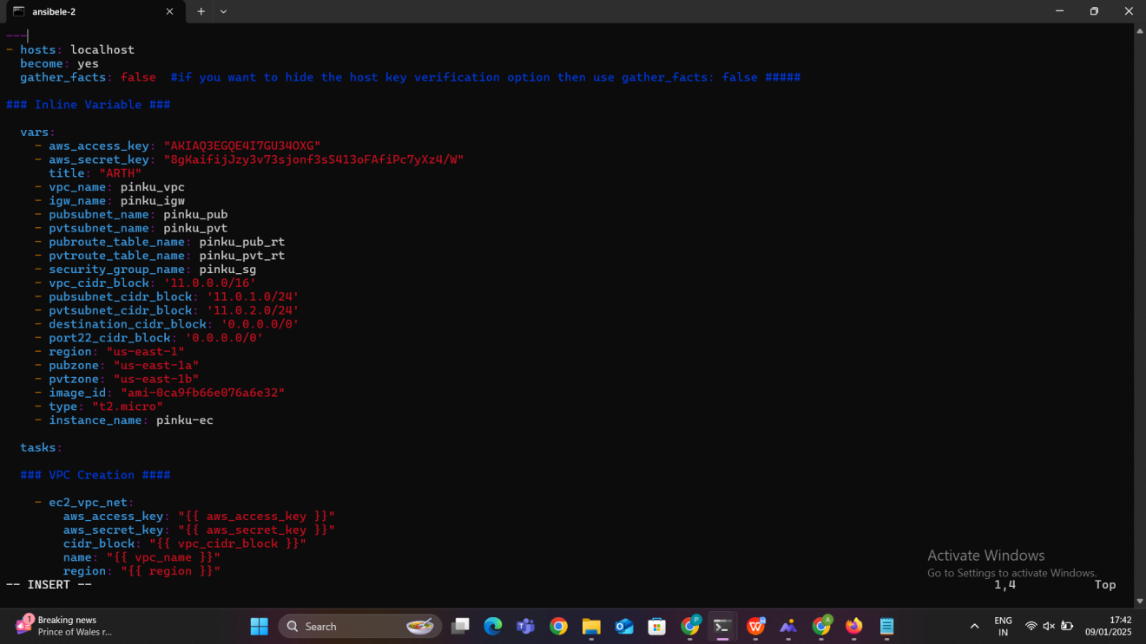

### ****1. Inline Variables****

This section defines all necessary variables for AWS credentials, resource names, CIDR blocks, availability zones, and instance details.

* aws_access_key and aws_secret_key: AWS credentials for authentication.
* Resource names (vpc_name, igw_name, pubsubnet_name, etc.) ensure proper tagging and identification of resources.
* CIDR blocks (vpc_cidr_block, pubsubnet_cidr_block, etc.) define the IP ranges for the VPC and subnets.
* region: AWS region for resource deployment.
* image_id: AMI ID for the EC2 instance.
* type: Instance type (e.g., t2.micro).
* pubzone and pvtzone: Availability zones for the public and private subnets.

### ****2. Internet Gateway Creation****

* **Objective**: The Internet Gateway (IGW) is a component that allows communication between resources inside the VPC and the internet.
* **What happens**:
  + The playbook creates an IGW and attaches it to the VPC created earlier.
  + This enables the VPC to route outbound and inbound traffic to/from the internet.
* **Key Attributes**:
  + The IGW is tagged with a name for identification.
  + The state is set to present, ensuring the IGW exists

### ****3. Public Subnet Creation****

* **Objective**: Subnets divide the IP range of a VPC into smaller sections and can be configured as public or private.
* **What happens**:
  + A public subnet is created with a specific CIDR block within the VPC.
  + The map_public option is enabled, which allows instances in the subnet to receive a public IP address.
* **Use case**: Instances in this subnet can directly communicate with the internet.

### ****4. Private Subnet Creation****

* **Objective**: Private subnets are used to host resources that do not require direct access to the internet.
* **What happens**:
  + A private subnet is created with a unique CIDR block in a different availability zone.
  + The map_public option is disabled, meaning instances will not automatically get public IPs.
* **Use case**: Suitable for databases, application servers, or other backend resources.

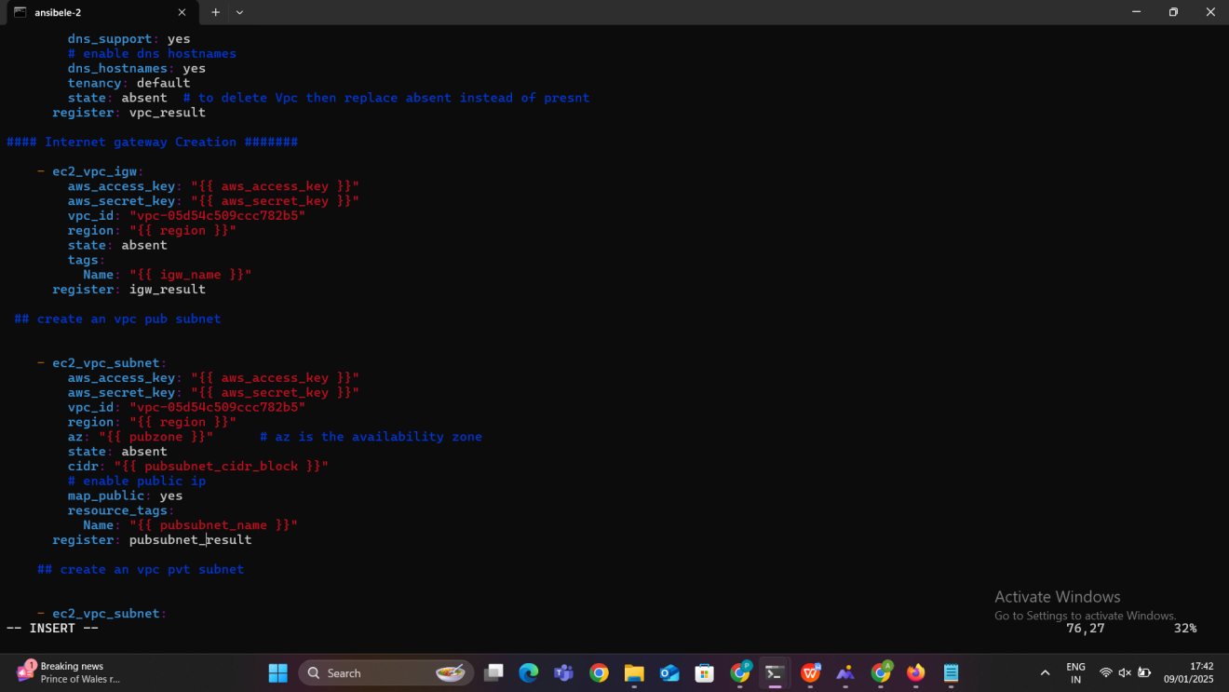

### ****5. Public Route Table Creation****

* **Objective**: A route table directs traffic within the VPC and to external destinations (e.g., the internet).
* **What happens**:
  + A route table is created for the public subnet.
  + A route is added to send all traffic (0.0.0.0/0) destined for the internet via the IGW.
* **Use case**: Ensures public subnet resources can communicate with the internet.

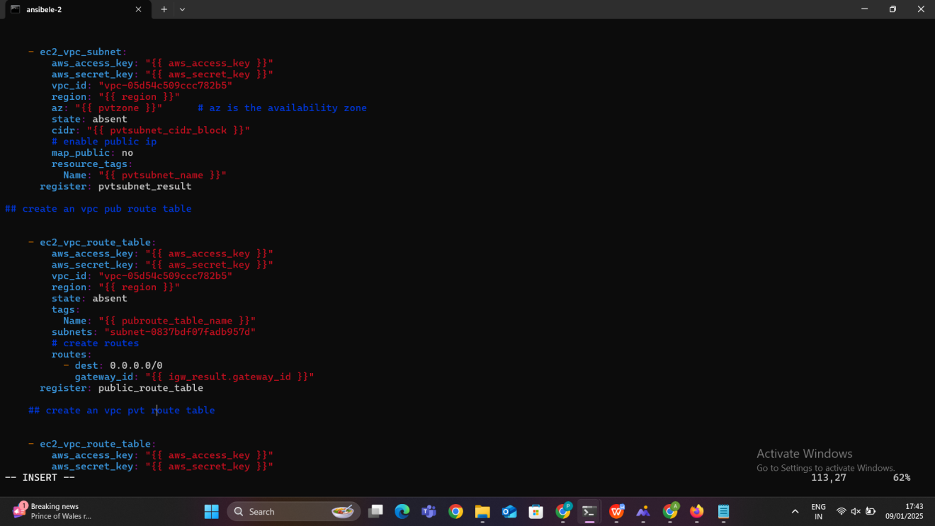

### ****6. Private Route Table Creation****

* **Objective**: The private route table ensures secure communication within the VPC.
* **What happens**:
  + A separate route table is created and associated with the private subnet.
  + No route to the internet is added, ensuring isolation from the internet.
* **Use case**: Resources in the private subnet, such as databases, remain secure.

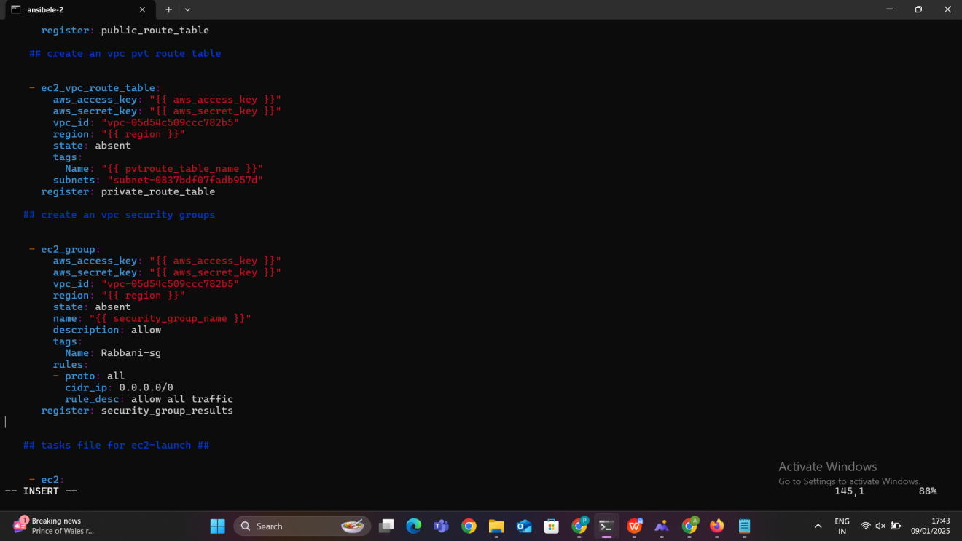

### ****7. Security Group Creation****

* **Objective**: Security groups act as virtual firewalls to control inbound and outbound traffic for resources in the VPC.
* **What happens**:
  + A security group is created and attached to the VPC.
  + It allows all traffic by default in this playbook but can be customized for specific protocols and ports.
* **Use case**: Provides network-level security for EC2 instances or other AWS resources.

### ****8. EC2 Instance Launch****

* **Objective**: Launch an EC2 instance as a virtual server in the cloud.
* **What happens**:
  + The EC2 instance is launched in the public subnet with a specified instance type (t2.micro) and AMI (Amazon Machine Image).
  + It is associated with the security group created earlier for controlled traffic.
  + The instance is automatically assigned a public IP, allowing external access.
* **Use case**: This instance can be used as a web server, application host, or any other purpose as per requirements.

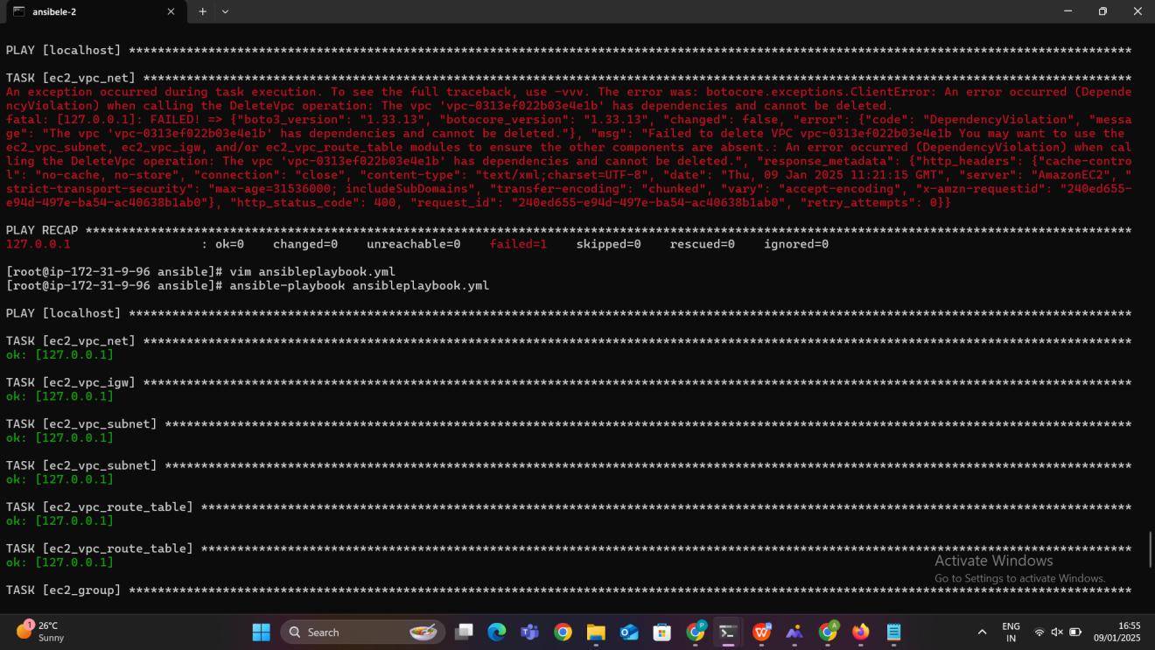

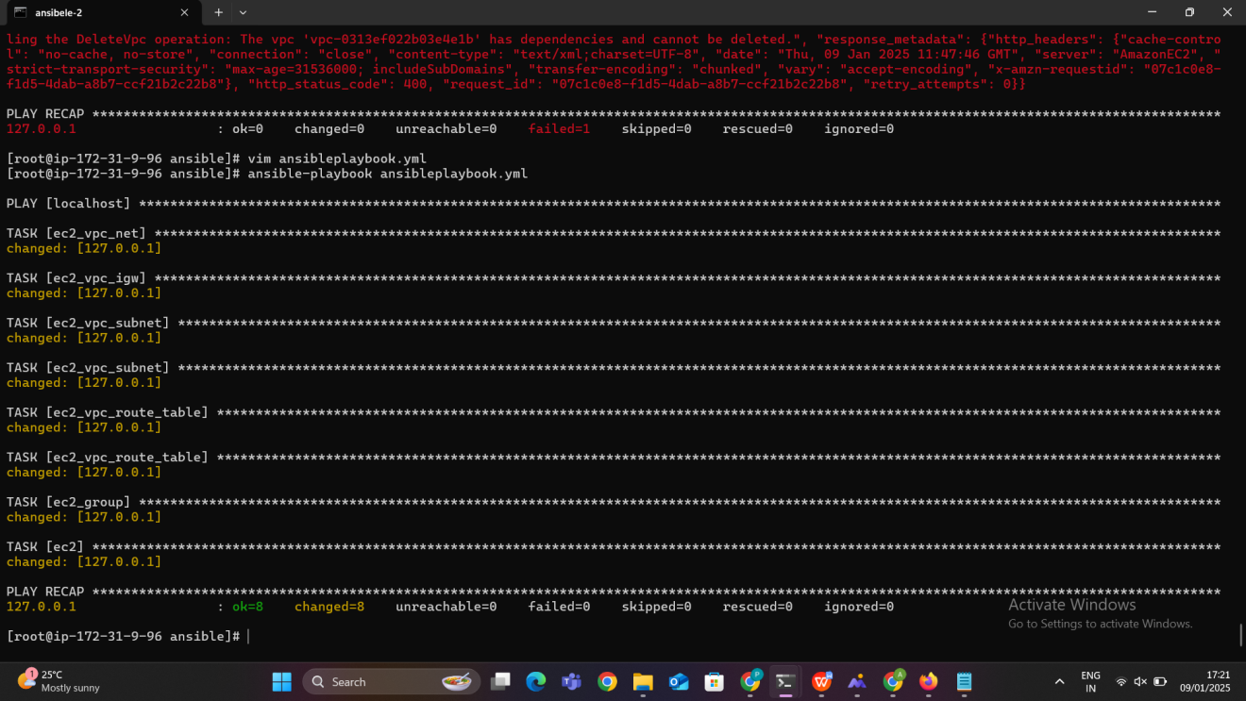

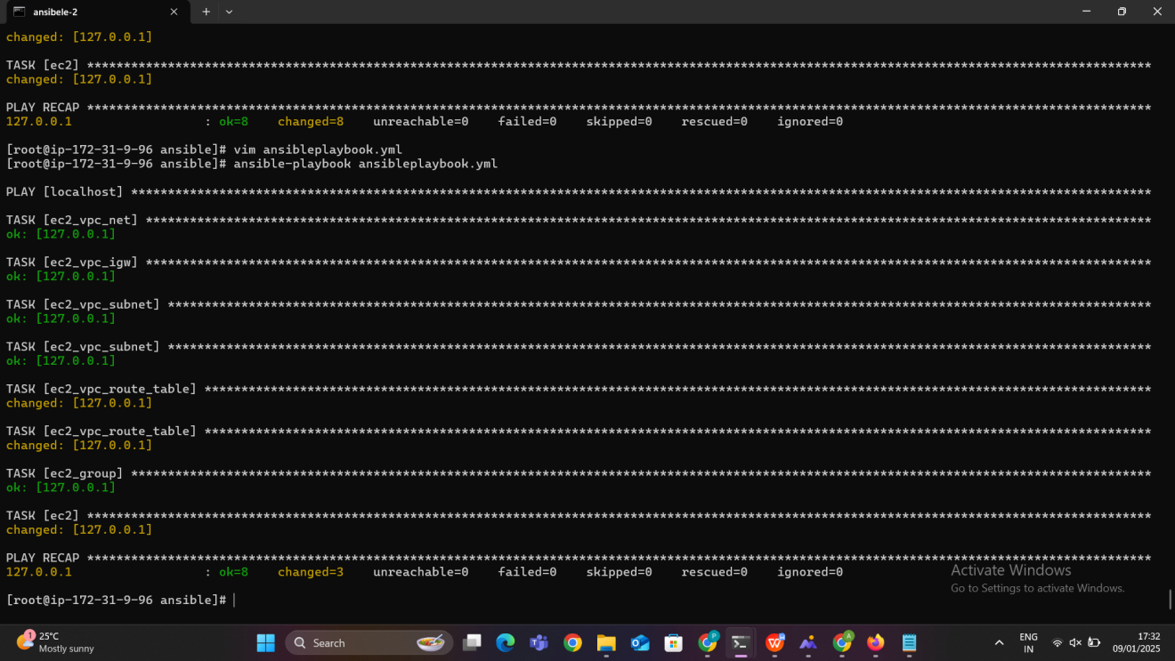

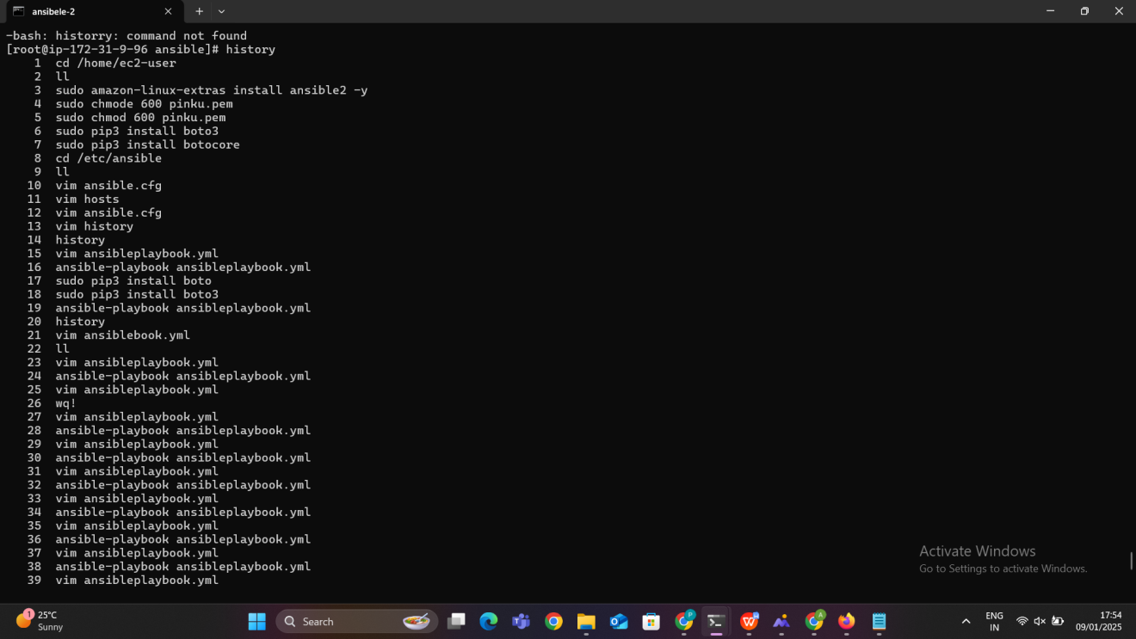

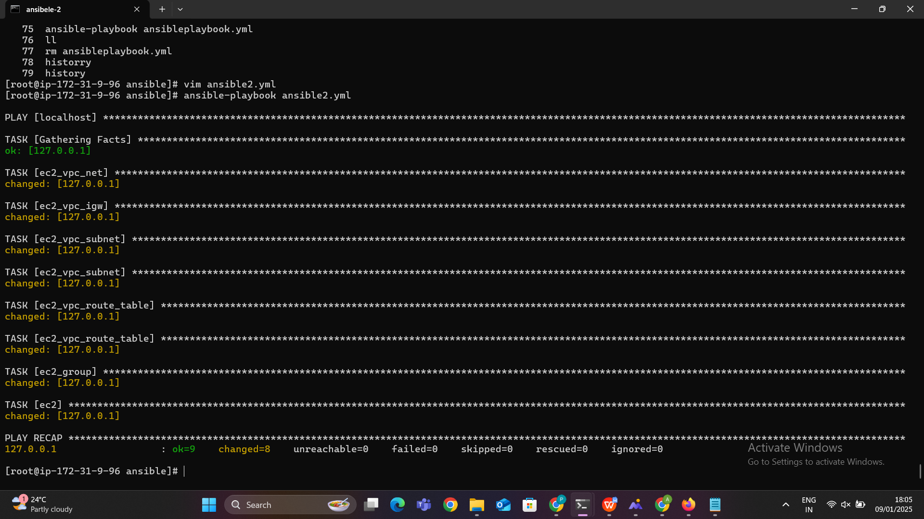

**Resource Creation**:

* 1. Resources such as VPC, Subnets, Security Groups, Internet Gateways, Route Tables, and EC2 instances will be created in AWS.
  2. Each resource is uniquely identified by an ID (e.g., VPC ID, Subnet ID, etc.) returned in the register variables.

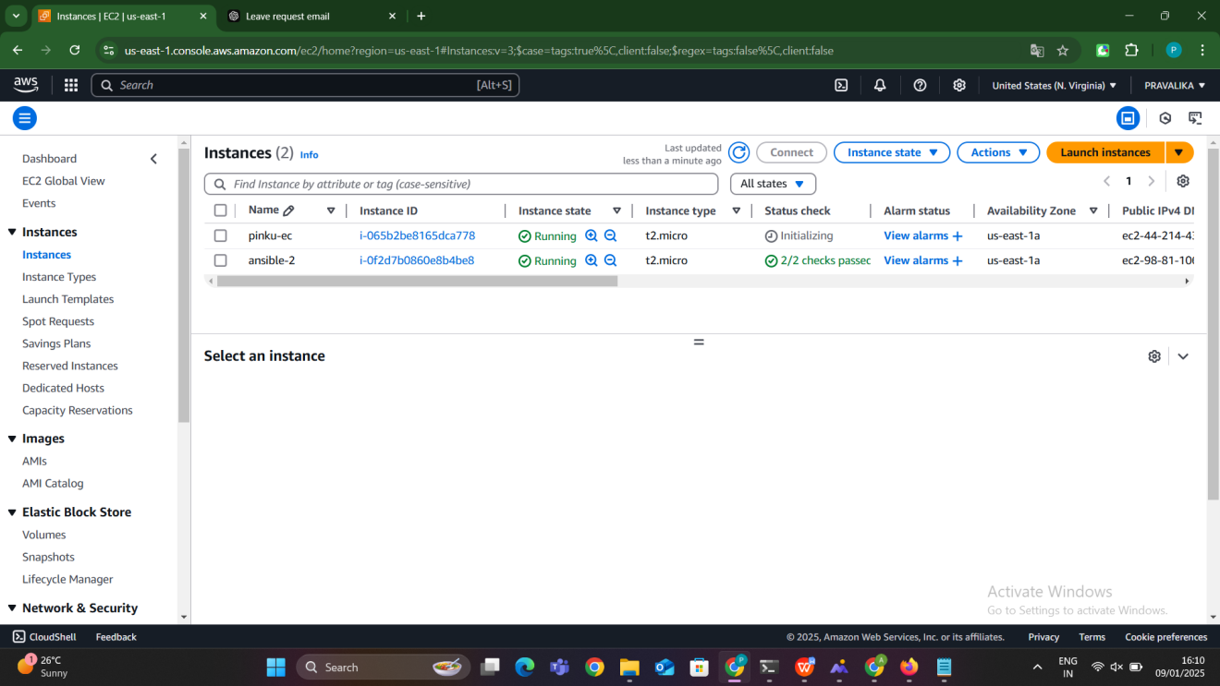

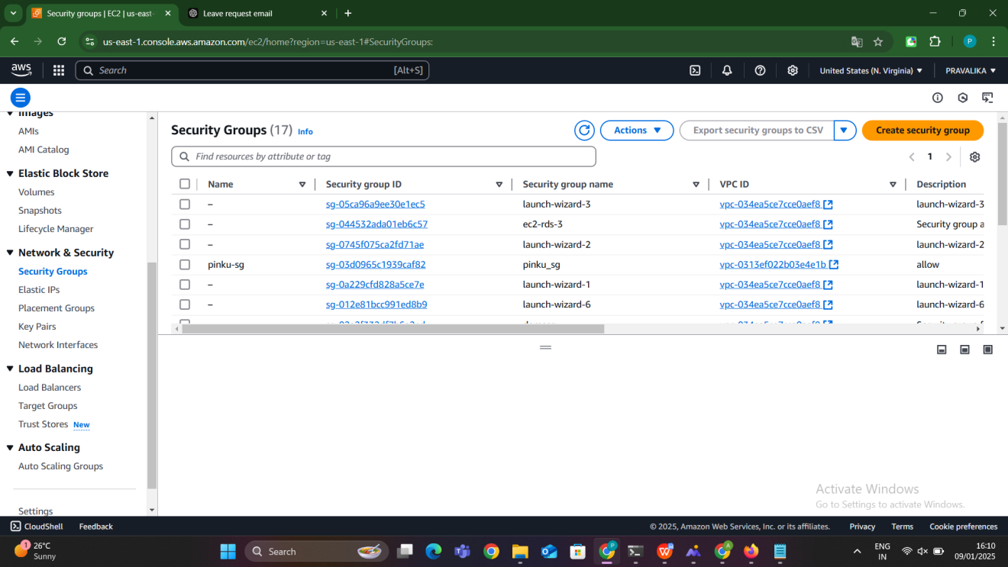

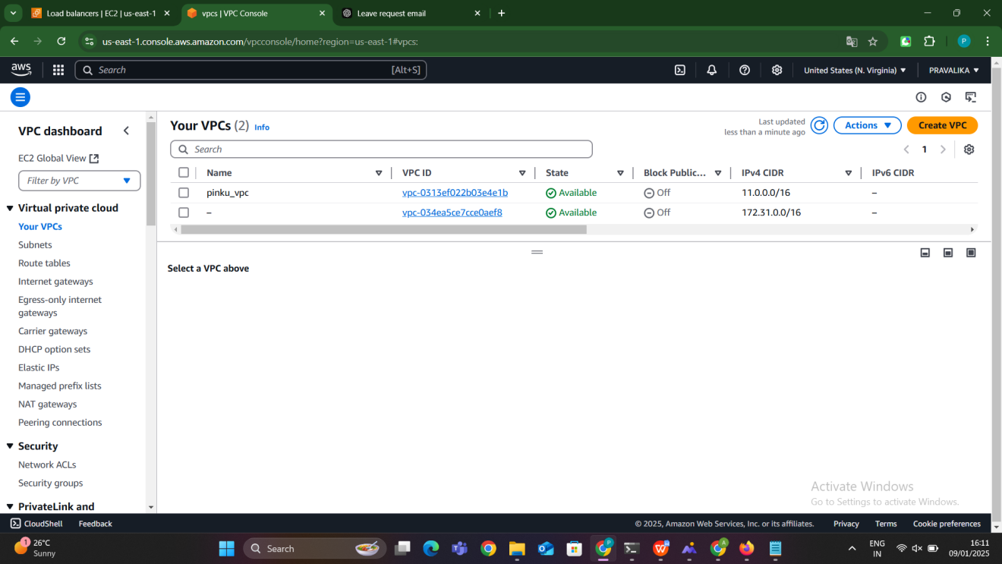

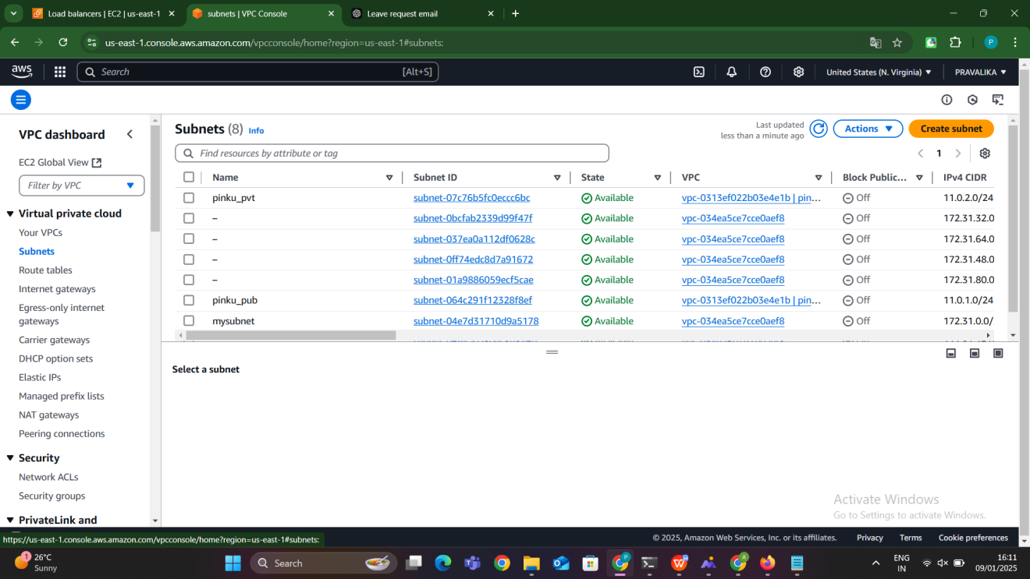

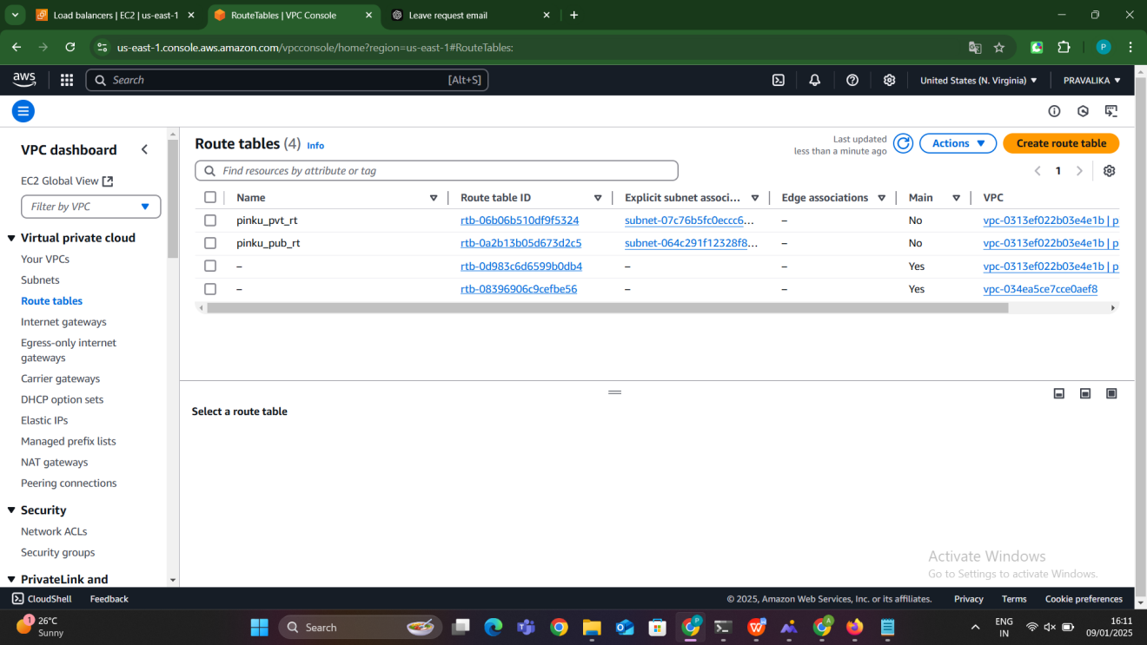

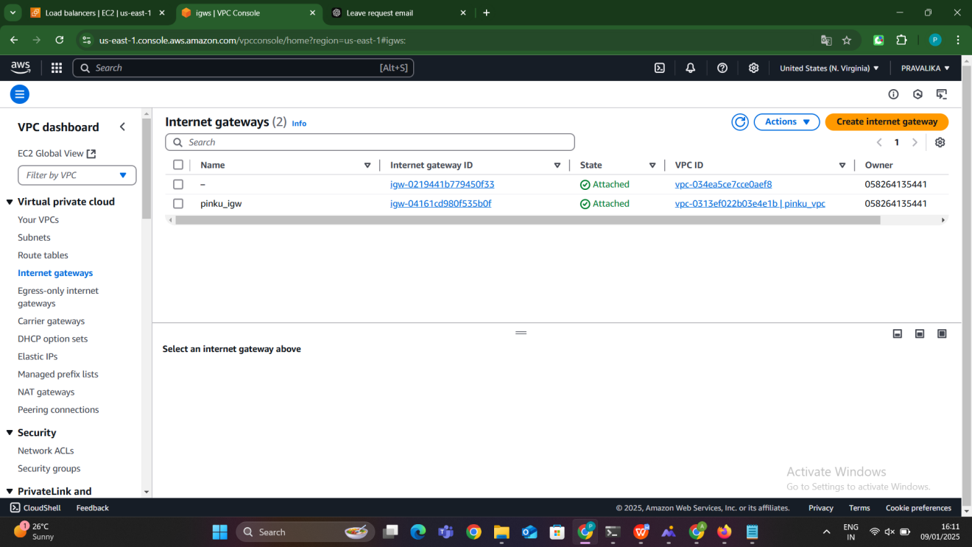

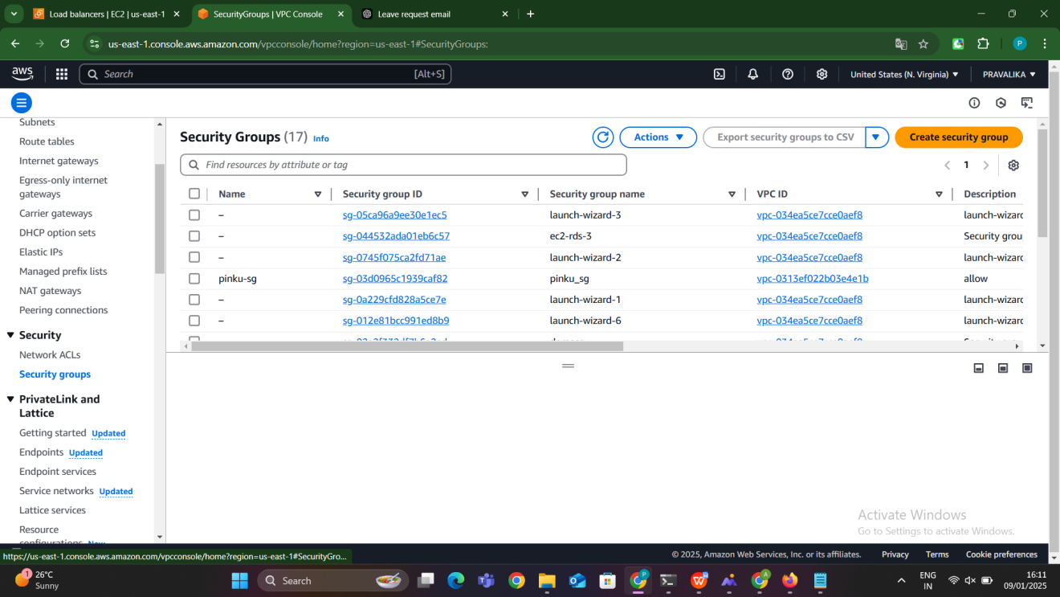

### ****Deleting Resources****

When resources are no longer needed, we must delete them in a specific **order** to avoid dependency issues. Use the following process:

**Modify the Playbook**:

* 1. Update the state parameter for each resource to absent, which signals Ansible to delete the resource.
  2. Provide the ID of each resource to ensure the correct one is deleted.

**Deletion Order**:

* 1. AWS resources depend on each other, so deletion must follow this order:

**Step 1: EC2 Instances**  
Delete EC2 instances first, as they depend on subnets, security groups, and route tables -

instance_ids: <EC2_INSTANCE_ID>

state: absent

**Step 2: Subnets**  
Delete subnets after EC2 instances, as they are associated with route tables.

- ec2_vpc_subnet:

subnet_id: <SUBNET_ID>

state: absent

**Step 3: Route Tables**  
Delete route tables after subnets are detached.

- ec2_vpc_route_table:

route_table_id: <ROUTE_TABLE_ID>

state: absent

**Step 4: Security Groups**  
Delete security groups after EC2 instances are terminated.

- ec2_group:

group_id: <SECURITY_GROUP_ID>

state: absent

**Step 5: Internet Gateway**  
Detach and delete the internet gateway after subnets and route tables are removed

- ec2_vpc_igw:

igw_id: <IGW_ID>

state: absent

**Step 6: VPC**  
Finally, delete the VPC itself once all dependencies are removed.

- ec2_vpc_net:

vpc_id: <VPC_ID>

state: absent

**Run the Playbook**:

* Execute the playbook with the updated states

--> ansible-playbook ansiblescript.yml

This will delete all the resources in the specified order.

### ****Why This Order?****

#### **1. EC2 Instances (First)**

* **Reason**: EC2 instances are tied to subnets and security groups.
  + Subnets cannot be deleted while EC2 instances are still running in them.
  + Security groups may be associated with EC2 instances, preventing their deletion.
* **Action**: Terminate all EC2 instances before deleting subnets or security groups.

#### **2. Subnets (Second)**

* **Reason**: Subnets are part of a VPC and are associated with route tables.
  + A VPC cannot be deleted if it has active subnets.
  + Route tables often have dependencies on subnets.
* **Action**: Delete all subnets after EC2 instances are removed.

#### **3. Route Tables (Third)**

* **Reason**: Route tables are associated with subnets or an internet gateway.
  + A VPC cannot be deleted if it has route tables linked to it.
  + Public route tables depend on an internet gateway, and private route tables depend on subnets.
* **Action**: Delete route tables after removing subnets.

#### **4. Security Groups (Fourth)**

* **Reason**: Security groups are linked to EC2 instances.
  + They cannot be deleted while they are in use by instances or referenced in other configurations.
* **Action**: Delete security groups after EC2 instances and route tables are removed.

#### **5. Internet Gateways (Fifth)**

* **Reason**: Internet gateways are attached to VPCs and linked through route tables.
  + A VPC cannot be deleted if it has an attached internet gateway.
  + Route tables with public routes depend on the internet gateway.
* **Action**: Detach and delete the internet gateway after route tables are removed.

#### **6. VPC (Last)**

* **Reason**: The VPC is the parent resource for all the above.
  + A VPC cannot be deleted unless all its associated resources are removed.
* **Action**: Delete the VPC after ensuring no dependencies remain.

**Method-2:AWS resources creation using ansible playbook with out variables**

### Concept of an Ansible Playbook Without Variables

An **Ansible playbook without variables** refers to an Ansible playbook where all the parameters and configuration values (like resource names, IP ranges, keys, etc.) are **hardcoded directly into the script**. This means that instead of using variables (which can be dynamic or passed in during execution), the values are directly specified in the playbook tasks themselves.

### Key Characteristics of Playbooks Without Variables

**Hardcoded Values**: All values required for tasks, such as AWS access keys, instance types, VPC CIDR blocks, etc., are explicitly written in the playbook itself. There is no flexibility to reuse or modify the playbook dynamically.

**Simpler to Write**: Since there are no variables or external files, the playbook is relatively straightforward to write and understand, especially for simpler, one-off tasks or small-scale configurations.

**Not Reusable**: This type of playbook is **static**, meaning it is difficult to adapt it to different environments (e.g., different regions, different IP address ranges, or different configurations) without manually editing the playbook every time you want to change something.

**No External Dependency**: Since the values are written directly in the playbook, there is no need for external files, templates, or variable definitions.

**Security Risk**: One major drawback is that **sensitive data** like passwords, access keys, and tokens are hardcoded into the playbook. If this playbook is shared or stored improperly, it could lead to security vulnerabilities.

### Advantages of Using a Playbook Without Variables

1. **Simplicity**: It is easy to write and understand, especially for beginners or one-time tasks.
2. **No Extra Setup**: You don’t need to define extra variable files, playbook parameters, or dynamic inventory.
3. **Quick to Execute**: You can quickly execute the playbook without having to configure anything else.

### Disadvantages of Using a Playbook Without Variables

1. **Hard to Reuse**: It’s not easy to adapt this playbook for different environments, regions, or projects. You need to manually change the values each time.
2. **Risk of Errors**: Since there are no checks or validation mechanisms for input values, it increases the chances of errors due to hardcoded values.
3. **Security Risks**: Hardcoding sensitive data such as AWS credentials and passwords exposes these credentials if the playbook is accidentally shared or stored insecurely.
4. **Scalability**: For larger projects or teams, managing a playbook without variables can become cumbersome and error-prone, especially if you need to scale or make frequent changes.

- Create one ec2-instance and connect this using terminal ,then go the path where your key pair exist there use this command

Move to the path of our pem file their type this command :

scp -i pinku.pem pinku.pem ec2-user@publicip:/home/ec2-user

**Explanation:**

scp

* 1. Stands for **Secure Copy Protocol**.
  2. It is used to securely transfer files between a local machine and a remote machine over SSH.

-i pinku.pem

* 1. Specifies the private key file (pinku.pem) to use for authentication.
  2. This private key corresponds to the key pair you used when creating the EC2 instance.
  3. It ensures secure access to the EC2 instance.

pinku.pem

* 1. This is the **source file** you want to copy.
  2. In this case, the file being copied is the pinku.pem key itself.

ec2-user

* 1. The **username** for logging into the remote EC2 instance.
  2. For Amazon Linux and some Ubuntu AMIs, ec2-user is the default username.
  3. For other AMIs, it may differ (e.g., ubuntu for Ubuntu instances).

@publicip

* 1. The **public IP address** of the EC2 instance.
  2. Replace publicip with the actual IP address of your EC2 instance.

:/home/ec2-user

* 1. The **destination path** on the EC2 instance where the file will be copied.
  2. In this case, the file will be copied to the /home/ec2-user directory of the EC2 instance.

### ****What Happens When You Run This Command?****

1. The scp command connects to the remote EC2 instance using the private key specified by -i pinku.pem.
2. It securely transfers the pinku.pem file from your local machine to the /home/ec2-user directory on the remote EC2 instance.

### ****Key Considerations****

**Ensure the Security of** pinku.pem

* 1. The .pem file is sensitive and provides access to your EC2 instance.
  2. chmod 600 pinku.pem

### Next go to the path /home/ec2-user there we find our pem file then Give permission to that pem file : sudo chmod 600 pinku.pem

### sudo chmod 600 pinku.pem

* **Purpose**: Sets the file permissions for the pinku.pem file to 600.
* **Details**:
  + chmod: Command to change file permissions.
  + 600: Grants read and write permissions to the file's owner, but no permissions to group members or others.

**Use case**: Ensures that the private key file (pinku.pem) is secure and only the owner can use it. This is required when using SSH to connect to an EC2 instance, as insecure key permissions will result in errors.





Write a ansible file for without variables ,name it as ansiblewithoutvariables.yml

1. **VPC Creation**

**- ec2_vpc_net:**

**aws_access_key: A\*\*\*\*\*\*\*\*\*\*\*\*\*\*\*\*\***

**aws_secret_key: \*\*\*\*\*\*\*\*\*\*\*\*\*\*\*\*\*\*\***

**cidr_block: 10.0.0.0/16**

**name: pravalika-vpc**

**region: us-east-1**

**state: present**

· This task creates a VPC (Virtual Private Cloud) with the CIDR block 10.0.0.0/16.

· aws_access_key and aws_secret_key are hardcoded for accessing AWS resources. (This is insecure for production use; it's better to use IAM roles or AWS credentials files for security).

· state: present means that the VPC will be created. If you change it to absent, it will delete the VPC.

· register: vpc_result saves the result of this task (like the VPC ID) for use in later tasks.

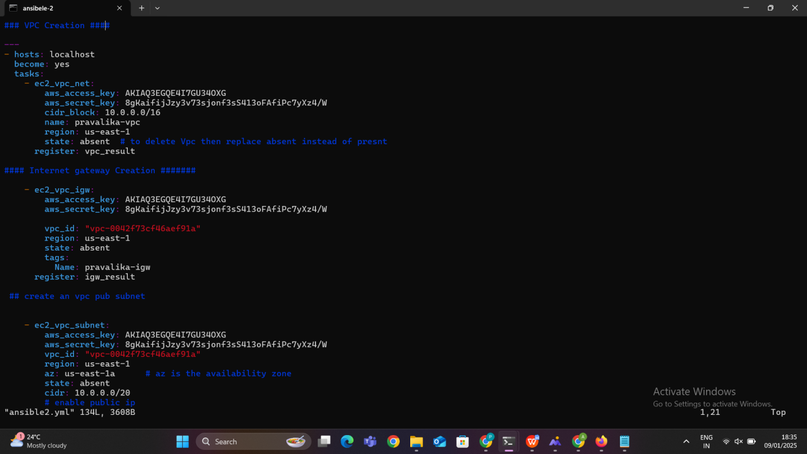

### ****Internet Gateway Creation:****

### **- ec2_vpc_igw:**

### **aws_access_key: \*\*\*\*\*\*\*\*\*\*\*\*\***

### **aws_secret_key: 8\*\*\*\*\*\*\*\*\*\*\*\*\*\*\*\*\***

### **vpc_id: "{{ vpc_result.vpc.id }}"**

### **region: us-east-1**

### **state: present**

### **tags:**

### **Name: pravalika-igw**

· Creates an **Internet Gateway (IGW)** and associates it with the VPC created in the previous task.

· The vpc_id is dynamically referenced from the output of the previous task (vpc_result.vpc.id).

· state: present creates the IGW if it does not exist.

· tags: Name: pravalika-igw gives a name tag to the gateway for identification

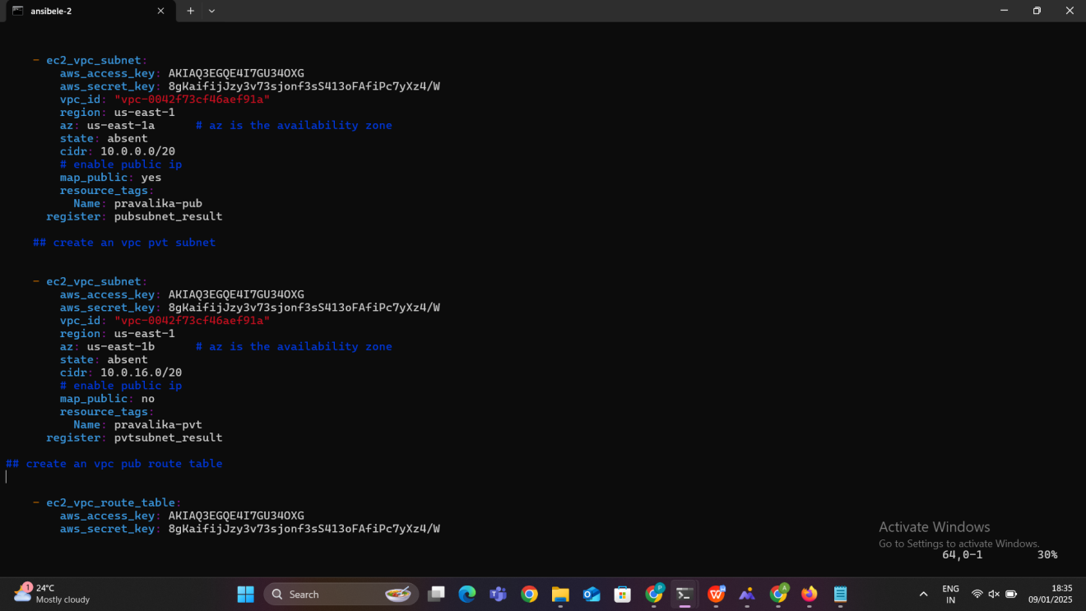

1. **Public Subnet Creation:**

**- ec2_vpc_subnet:**

**aws_access_key: \*\*\*\*\*\*\*\*\*\*\*\*\*\*\*\*\*\*\*\*\*\***

**aws_secret_key: 8\*\*\*\*\*\*\*\*\*\*\*\*\*\*\*\*\*\*\*\*\*\*\***

**vpc_id: "{{ vpc_result.vpc.id }}"**

**region: us-east-1**

**az: us-east-1a**

**state: present**

**cidr: 10.0.0.0/20**

**map_public: yes**

**resource_tags:**

**Name: pravalika-pub**

· This creates a **public subnet** in the VPC using the CIDR block 10.0.0.0/20.

· The map_public: yes ensures that this subnet will have a public IP address.

· The subnet is created in the us-east-1a availability zone.

· resource_tags: Name: pravalika-pub tags the subnet for easy identification.

### 4. ****Private Subnet Creation****

- ec2_vpc_subnet:

aws_access_key: A**************

aws_secret_key: 8****************

vpc_id: "{{ vpc_result.vpc.id }}"

region: us-east-1

az: us-east-1b

state: present

cidr: 10.0.16.0/20

map_public: no

resource_tags:

Name: pravalika-pvt

· Creates a **private subnet** in the us-east-1b availability zone with the CIDR block 10.0.16.0/20.

· map_public: no ensures that this subnet will not assign public IP addresses to instances launched within it.

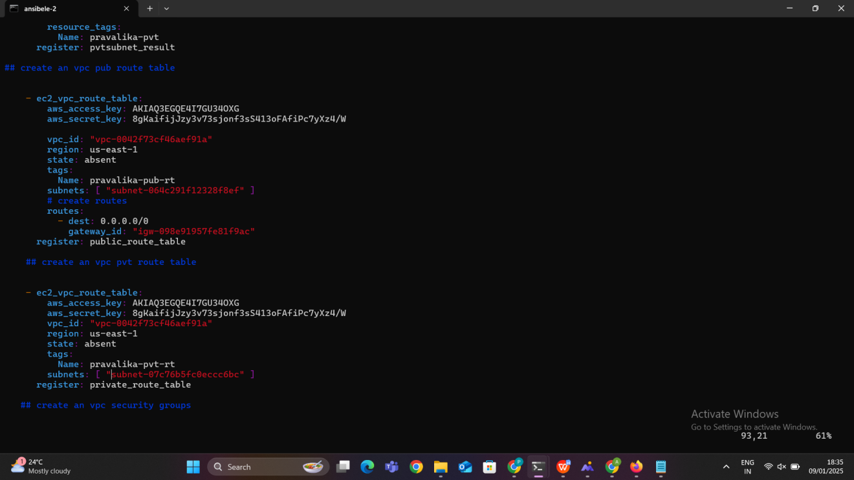

1. **Public Route Table Creation:**

**- ec2_vpc_route_table:**

**aws_access_key: A\*\*\*\*\*\*\*\*\*\*\*\*\*\*\*\*\***

**aws_secret_key: 8\*\*\*\*\*\*\*\*\*\*\*\*\*\*\*\*\*\*\*\***

**vpc_id: "{{ vpc_result.vpc.id }}"**

**region: us-east-1**

**state: present**

**tags:**

**Name: pravalika-pub-rt**

**subnets: [ "{{ pubsubnet_result.subnet.id }}" ]**

**routes:**

**- dest: 0.0.0.0/0**

**gateway_id: "{{ igw_result.gateway_id }}"**

· Creates a **route table** for the public subnet.

· The routes block adds a default route (0.0.0.0/0) that routes traffic through the **Internet Gateway (IGW)**.

1. **Private Route Table Creation:**

**- ec2_vpc_route_table:**

**aws_access_key: A\*\*\*\*\*\*\*\*\*\*\***

**aws_secret_key: 8\*\*\*\*\*\*\*\*\*\*\*\*\*\***

**vpc_id: "{{ vpc_result.vpc.id }}"**

**region: us-east-1**

**state: present**

**tags:**

**Name: pravalika-pvt-rt**

**subnets: [ "{{ pvtsubnet_result.subnet.id }}" ]**

Creates a **private route table** for the private subnet. Since no explicit route is specified, it will not have internet access unless another route is added (e.g., via a NAT gateway

1. **Security Group Creation:**

**- ec2_group:**

**aws_access_key: A\*\*\*\*\*\*\*\*\*\*\*\*\*\*\*\*\*\*\*\*\***

**aws_secret_key: 8\*\*\*\*\*\*\*\*\*\*\*\*\*\*\*\*\*\*\*\*\*\***

**vpc_id: "{{ vpc_result.vpc.id }}"**

**region: us-east-1**

**state: present**

**name: pravalika-sg**

**description: allow**

**tags:**

**Name: pinku-sg**

**rules:**

**- proto: all**

**cidr_ip: 0.0.0.0/0**

**rule_desc: allow all traffic**

· Creates a **security group** named pravalika-sg in the VPC.

· The rules block allows all traffic (proto: all), effectively making the instances associated with this security group open to all traffic from any IP address.

1. **EC2 Instance Launch:**

· Launches an **EC2 instance** with the specified **AMI ID** and **instance type (**t2.micro**)**.

The EC2 instance is launched in the **public subnet** created earlier (vpc_subnet_id points to pubsubnet_result.subnet.id).

· assign_public_ip: yes ensures the EC2 instance will have a public IP address.

· group_id associates the security group created earlier with the instance.

· instance_tags adds a tag to the EC2 instance for identification.

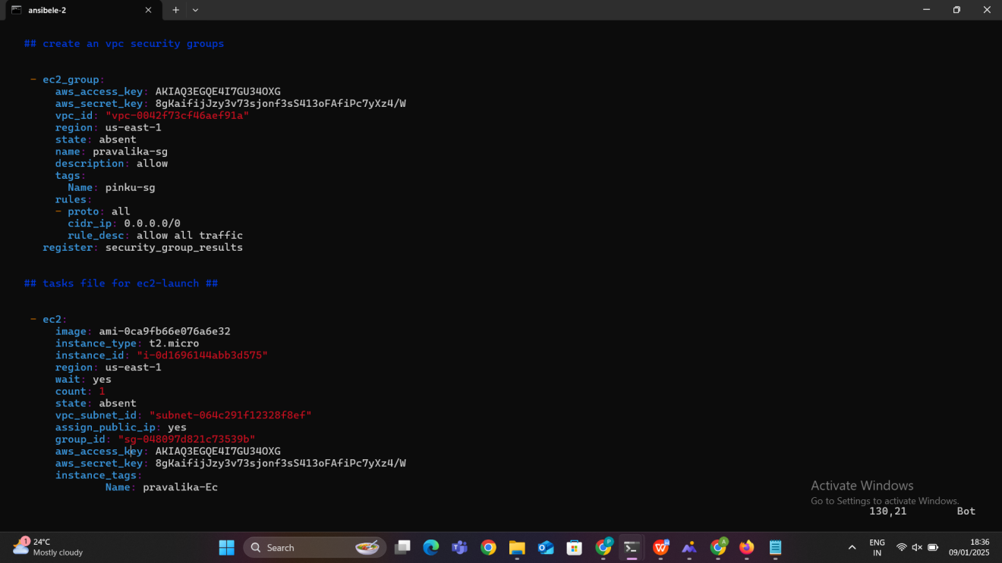

Run the playbook using ansible-playbook filename,then all the resources are created we can verify those resources in our aws console

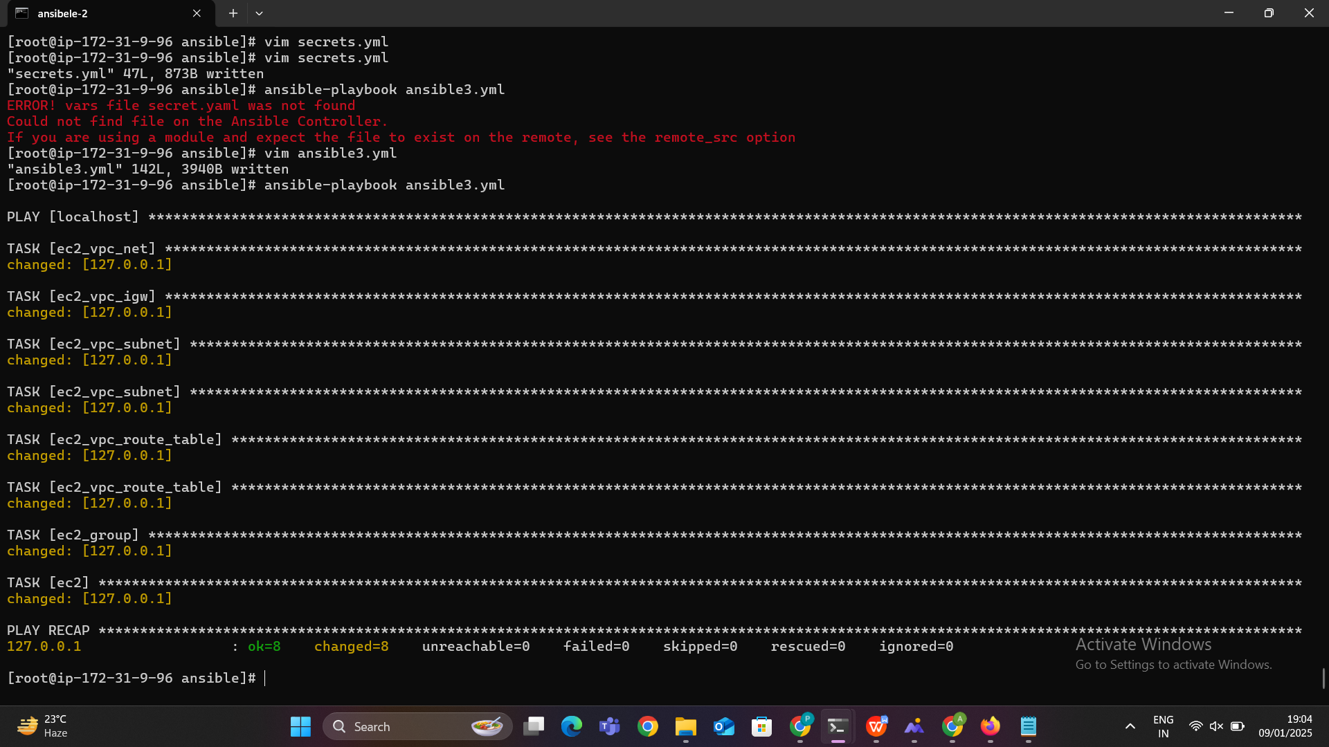



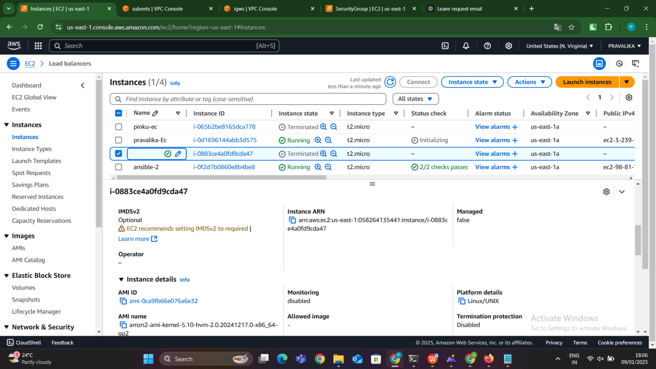

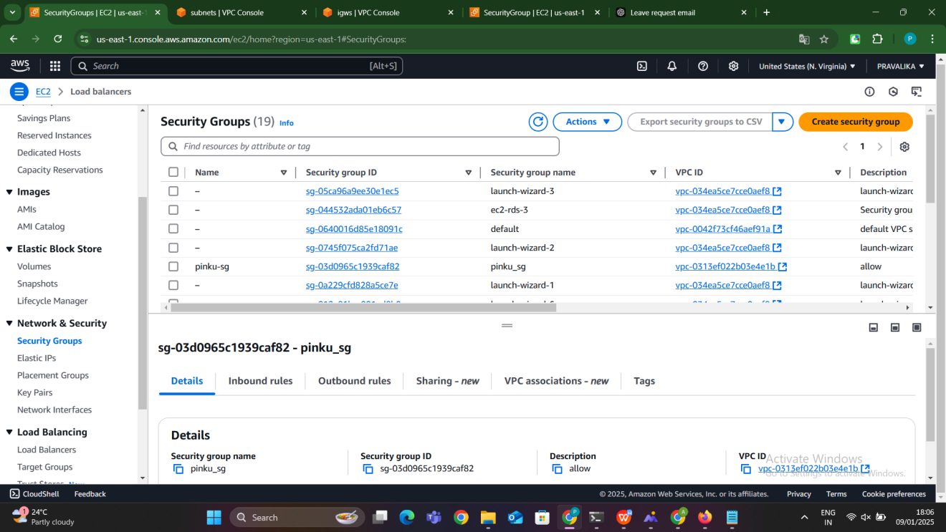

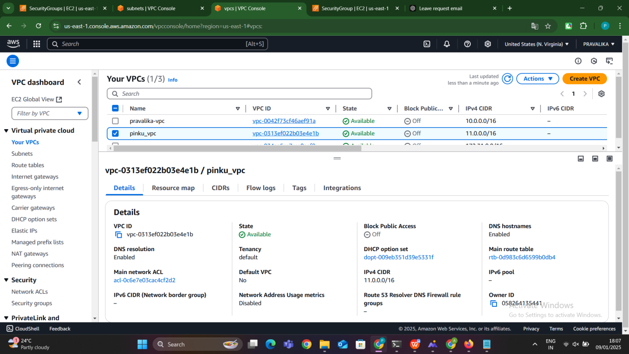

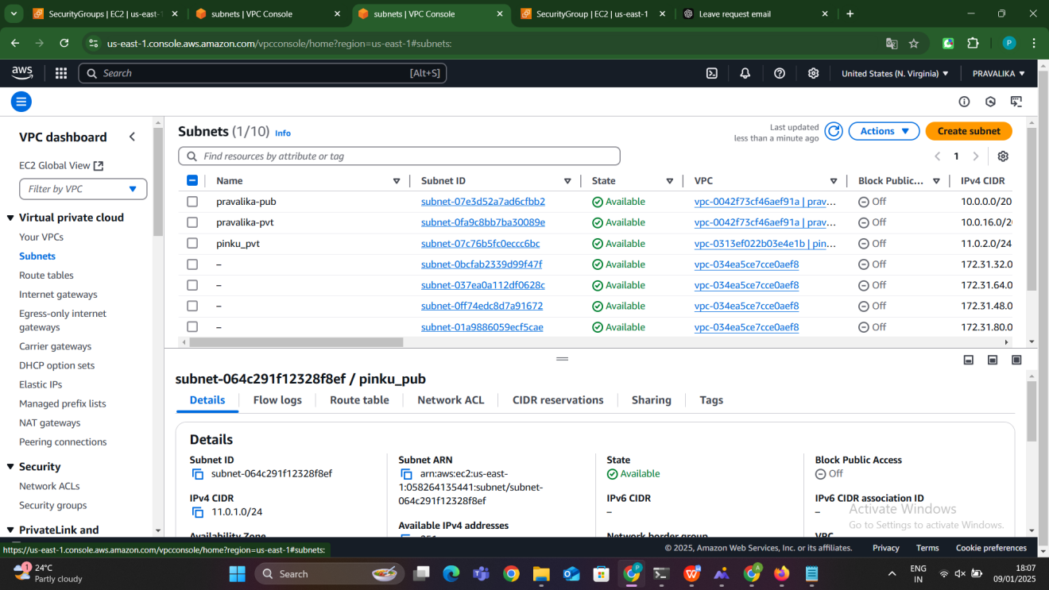

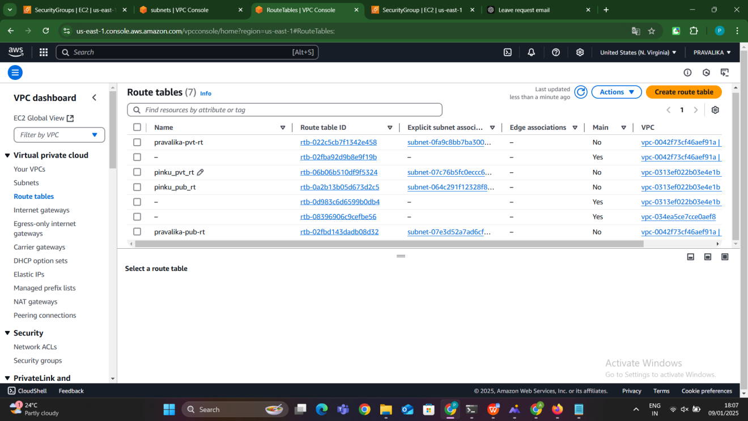

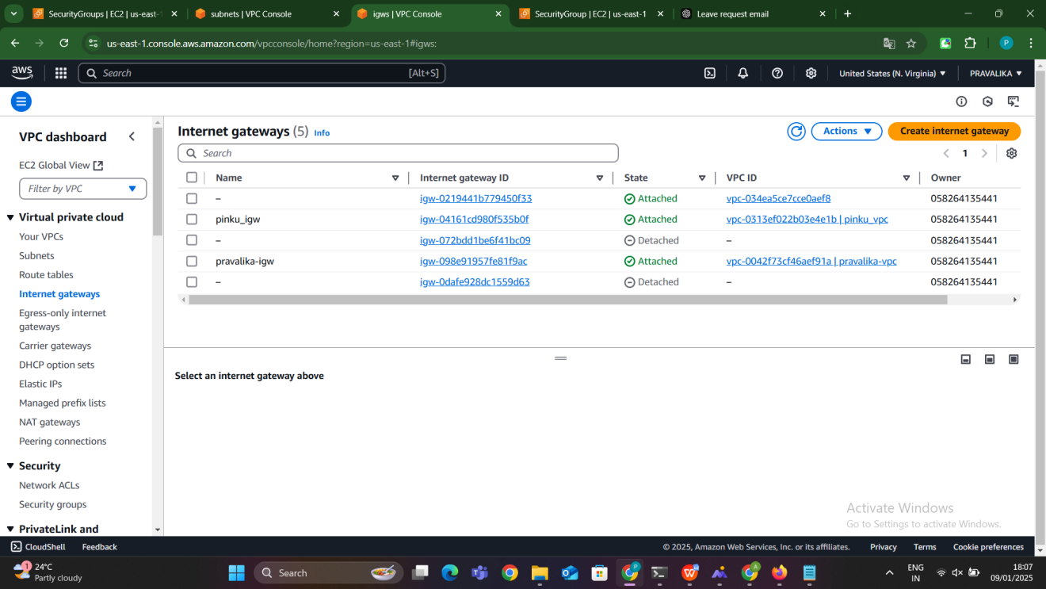

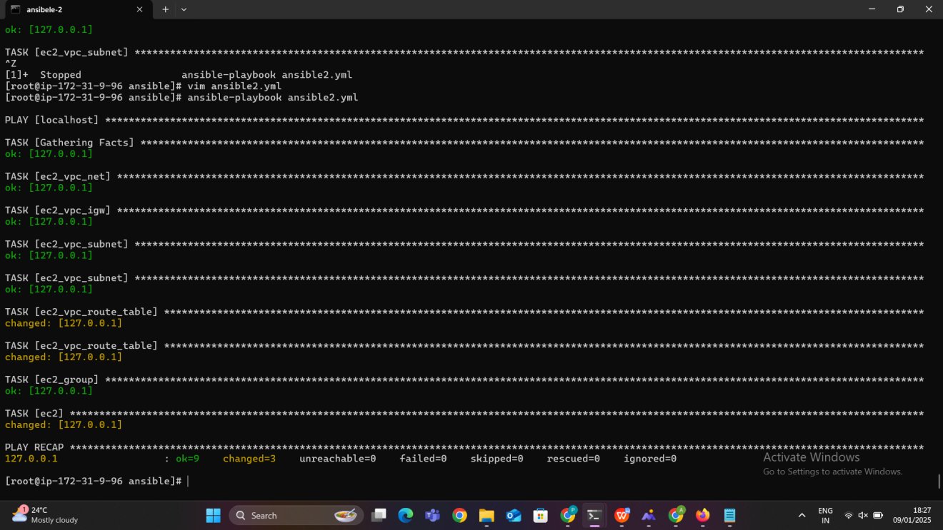

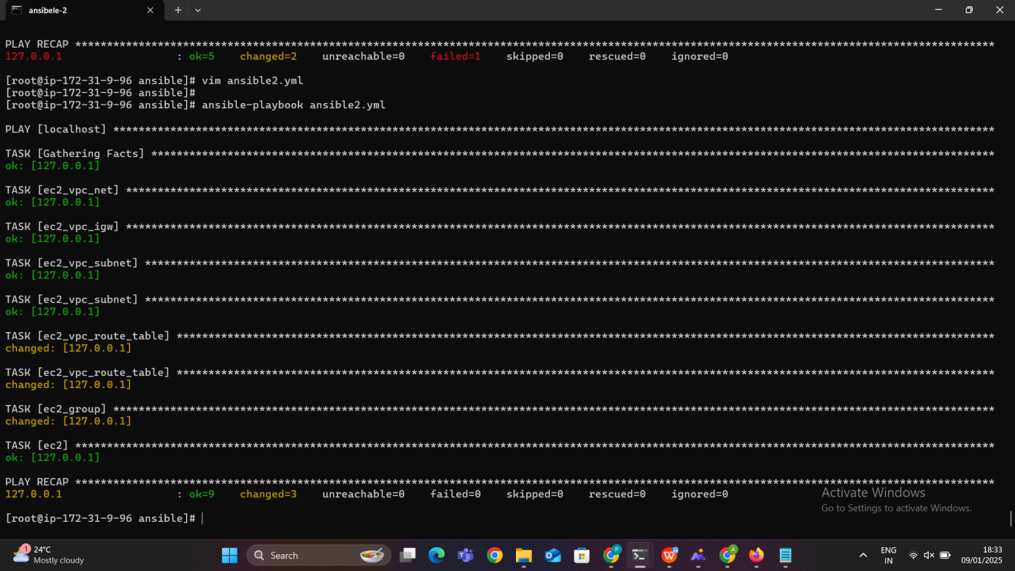

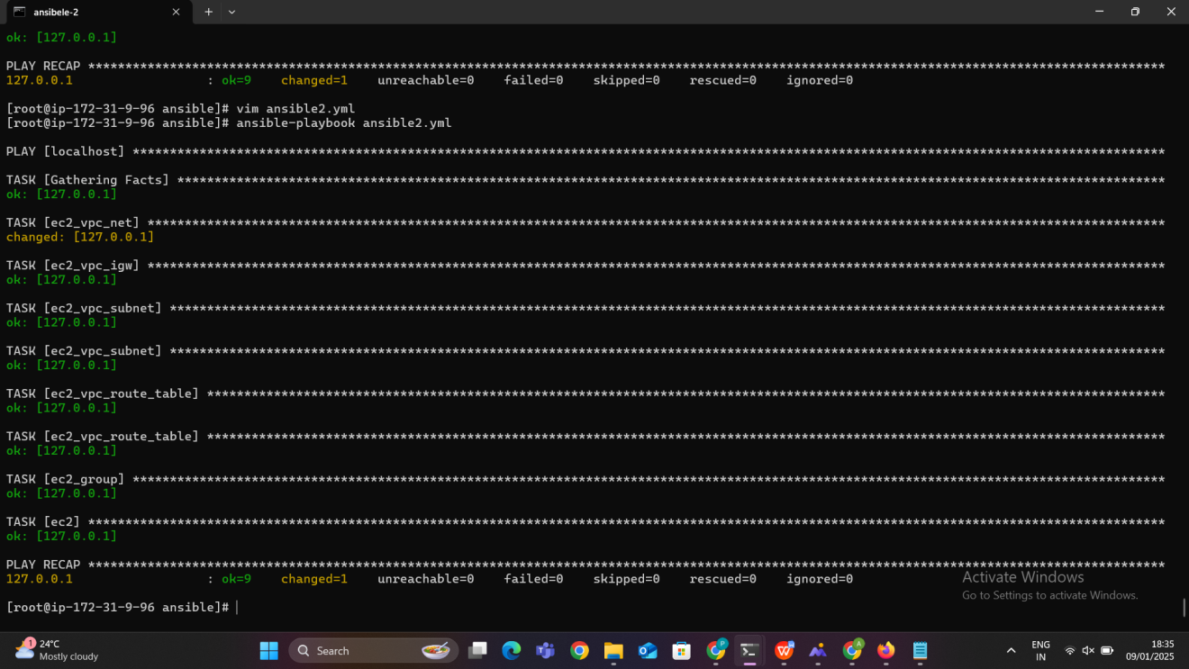

After creation we can able to delete those resources by giving state as absent in the ansible playbook script then the resouces what we have created will be deleted after running the playboook.

**Method-3: AWS resources creation using ansible playbook with outline variables**

### Concept of Ansible Outline Variables (Simplified)

Ansible **outline variables** are variables that are defined in **external files** (like a separate YAML file, e.g., secrets.yml) and then referenced inside the main Ansible playbook. This helps separate **configuration details** (e.g., AWS credentials, regions) from the playbook logic, making it cleaner and easier to maintain.

### Key Concepts:

**External File for Variables**: You can store sensitive or environment-specific information in separate files (e.g., secrets.yml) and load them into the playbook.

**Separation of Concerns**: It keeps your playbook focused on the task, while the configuration data (like credentials) is kept in separate files, making your playbook cleaner and easier to manage.

**Reusability**: The variables can be reused in multiple playbooks, making the playbook more modular and promoting the DRY (Don’t Repeat Yourself) principle.

**Security**: Sensitive data (like AWS keys) is stored separately, reducing the risk of accidental exposure when sharing or version-controlling playbooks.

**Scalability**: You can easily scale by changing values in the variables file (e.g., changing regions or instance types) without needing to update the main playbook.





To achieve the task of creating AWS resources using Ansible Playbooks with outline variables (for managing AWS access and secret keys separately), we will break it down into two separate playbooks. One will store sensitive credentials in a secrets.yml file, and the other (ansible3.yml) will be used for the resource creation process. Here's the step-by-step process:

### Step-by-Step Process:

### ****Step 1: Create the**** secrets.yml ****File****

The secrets.yml file will store your **AWS access key** and **AWS secret key**. This will separate the credentials from the main playbook and make it easier to manage or modify them when needed.

**Create the** secrets.yml **file:**

The secresta.yaml file is a configuration file typically used for provisioning resources in **AWS** using tools like Terraform, Ansible, or Python

· aws_access_key **&** aws_secret_key: These are the credentials used to authenticate API requests to AWS services. They grant access to perform operations on your AWS account. ⚠️ **Important:** These credentials should never be hard-coded in files, as it poses a security risk. Instead, store them in AWS Secrets Manager, IAM roles, or an environment variable.

· title: A label or description for the setup, perhaps denoting the project or application name.

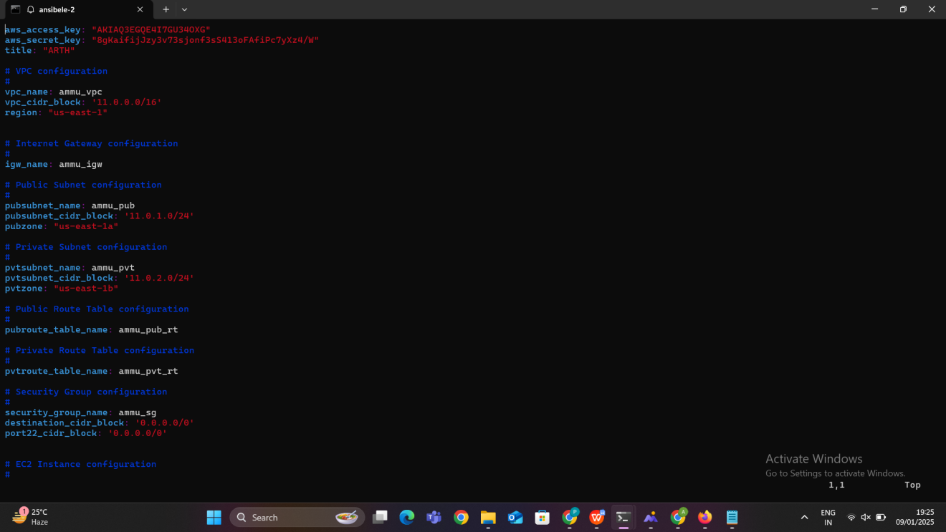

### ****Step 2: Create the**** ansible3.yml ****Playbook****

This is the main playbook where AWS resources will be created, and it will reference the credentials stored in secrets.yml.

**Create the** ansible3.yml **playbook:**

#### **Global Configuration**

1. **hosts**: Specifies localhost as the target host. The playbook runs locally to manage AWS infrastructure via API calls.
2. **become**: Enables privilege escalation.
3. **gather_facts**: Disabled to skip collecting facts about the localhost, as it’s unnecessary for this task.
4. **vars_files**: Includes secret.yaml, where sensitive variables such as AWS credentials and configuration values are stored.

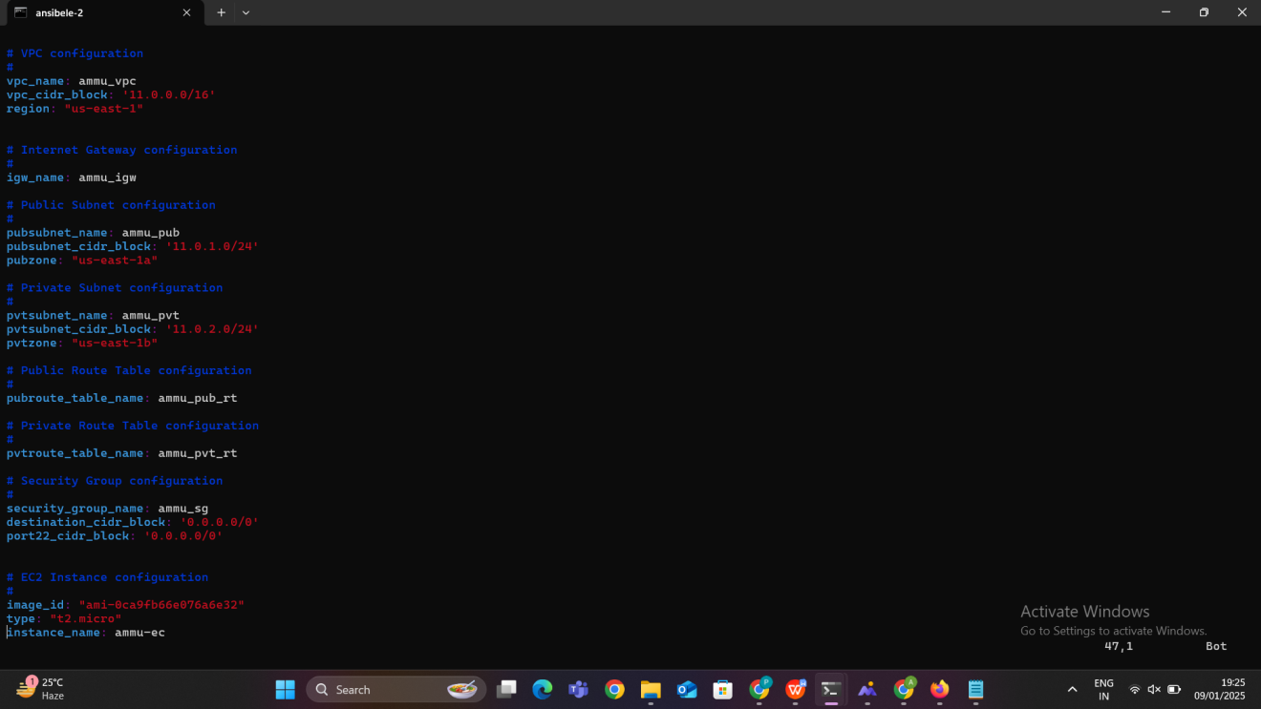

### ****Tasks****

#### **1. VPC Creation**

* **Module**: ec2_vpc_net
* **Description**: Creates a VPC with specified cidr_block, name, and region.
* **Key Options**:
  + dns_support and dns_hostnames enabled for DNS functionality.
  + tenancy set to default for shared tenancy.
* **Register**: Captures the result in vpc_result, which stores the VPC ID for subsequent tasks.

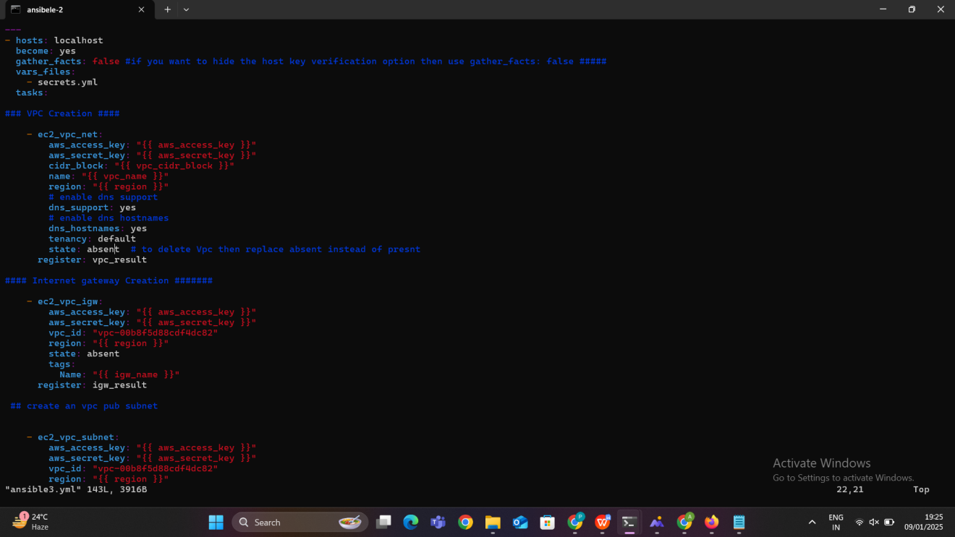

#### **2. Internet Gateway (IGW) Creation**

* **Module**: ec2_vpc_igw
* **Description**: Creates an Internet Gateway and attaches it to the newly created VPC.
* **Key Options**:
  + vpc_id: Links the IGW to the created VPC.
* **Register**: Stores the IGW details in igw_result.

#### **3. Public Subnet Creation**

* **Module**: ec2_vpc_subnet
* **Description**: Creates a public subnet within the VPC.
* **Key Options**:
  + az: Specifies the Availability Zone.
  + map_public: Enables automatic assignment of public IPs to instances in this subnet.
* **Register**: Stores the public subnet details in pubsubnet_result.

#### **4. Private Subnet Creation**

* **Module**: ec2_vpc_subnet
* **Description**: Creates a private subnet within the VPC.
* **Key Options**:
  + map_public: Disabled to prevent public IP assignment.
* **Register**: Stores the private subnet details in pvtsubnet_result.

#### **5. Public Route Table**

* **Module**: ec2_vpc_route_table
* **Description**: Creates a route table for the public subnet.
* **Key Options**:
  + Associates the subnet with the route table.
  + Adds a default route (0.0.0.0/0) via the Internet Gateway.
* **Register**: Captures the public route table details in public_route_table.

#### **6. Private Route Table**

* **Module**: ec2_vpc_route_table
* **Description**: Creates a route table for the private subnet.
* **Key Options**:
  + Links the private subnet to the route table.
* **Register**: Captures the private route table details in private_route_table.

#### **7. Security Group**

* **Module**: ec2_group
* **Description**: Creates a security group within the VPC.
* **Key Options**:
  + Allows all inbound and outbound traffic (proto: all, cidr_ip: 0.0.0.0/0).
* **Register**: Captures the security group ID in security_group_results.

#### **8. EC2 Instance Launch**

* **Module**: ec2
* **Description**: Launches an EC2 instance in the public subnet.
* **Key Options**:
  + Uses a predefined AMI (ami-033a1ebf088e56e81).
  + Associates the instance with the public subnet and security group.
  + Assigns a public IP.
  + Adds tags for identification.
* **Instance Tags**: Assigns a Name to the instance dynamically based on instance_name.

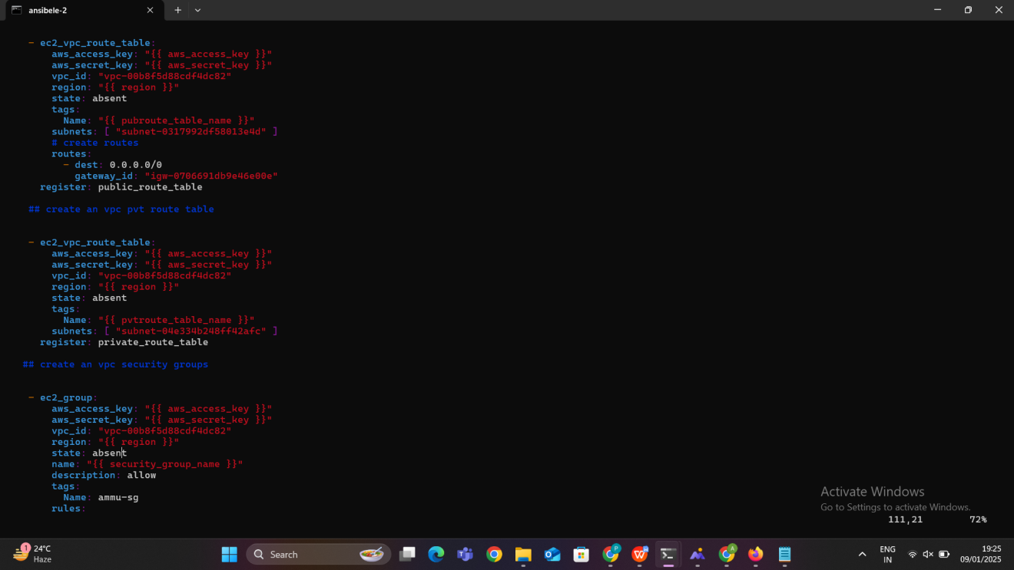

### ****Step 3 : Run the Playbook****

Now, we have both the secrets.yml file and the ansible3.yml playbook ready. Follow these steps to run the playbook and create AWS resources:

**Ensure that both files (**secrets.yml **and** ansible3.yml**) are in the same directory.**

**Run the playbook** using the ansible-playbook command:

### ****Step 4: Ansible Execution Flow****

* ansible3.yml will execute, and during this execution:
  + **AWS access keys** and **secret keys** will be loaded from the secrets.yml file using vars_files.
  + The playbook will sequentially execute the tasks for creating a VPC, Internet Gateway, subnets, security groups, and an EC2 instance.
  + After executing each task, Ansible will output the result of the operation (success or failure).

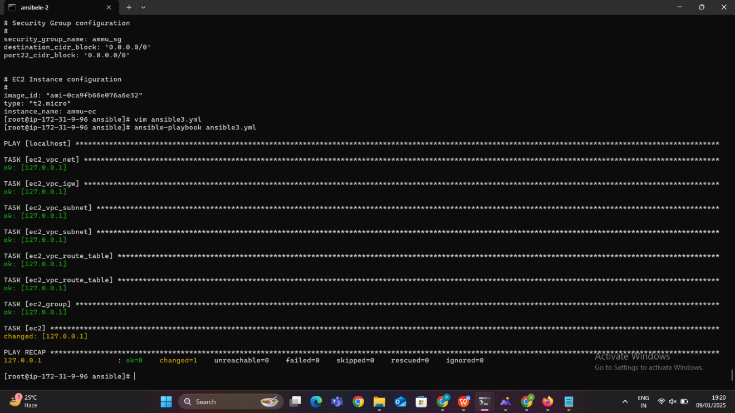

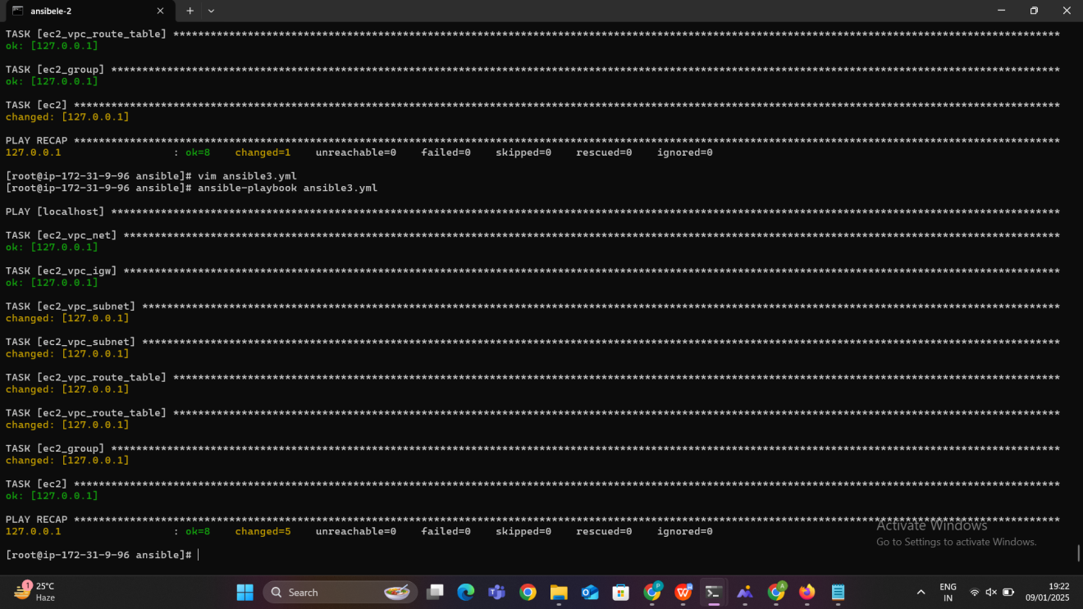

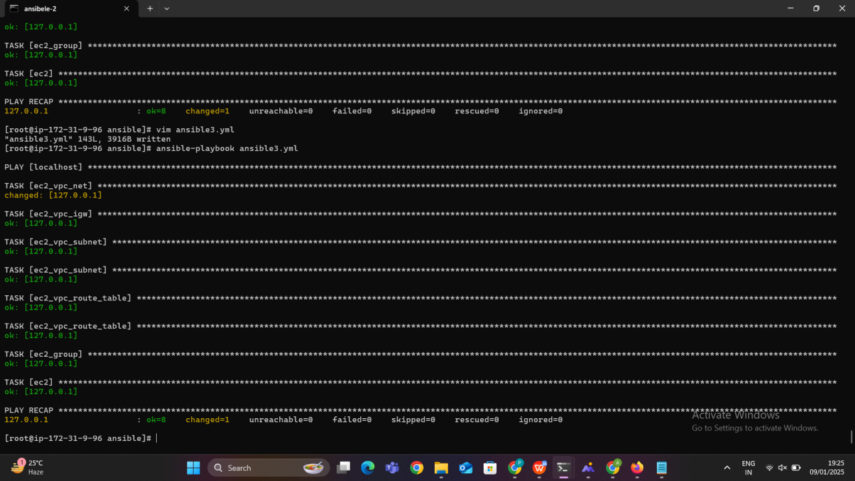

The resources will be created we can verify the creation in our aws console

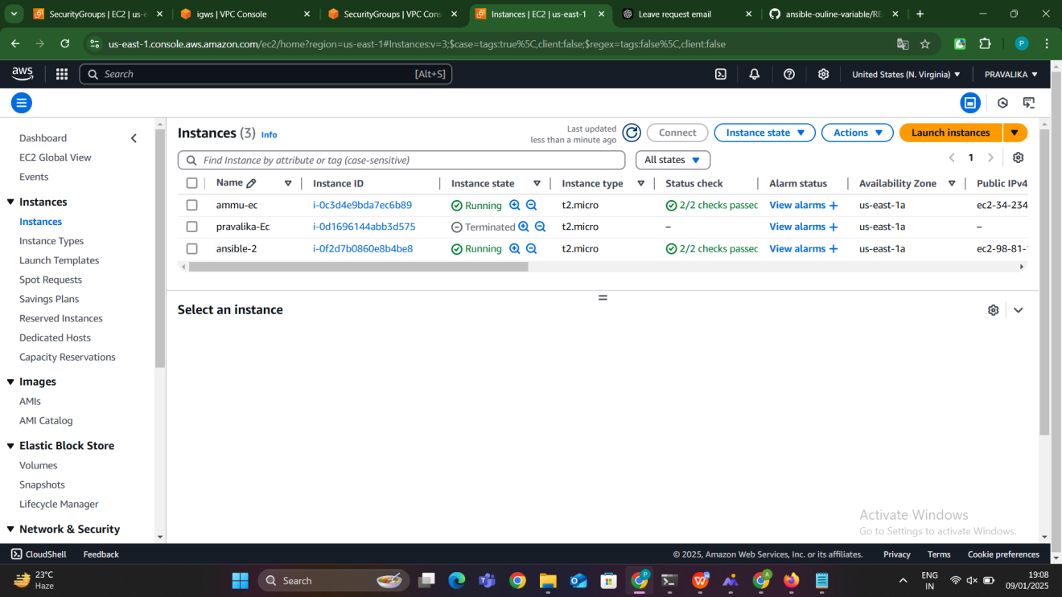

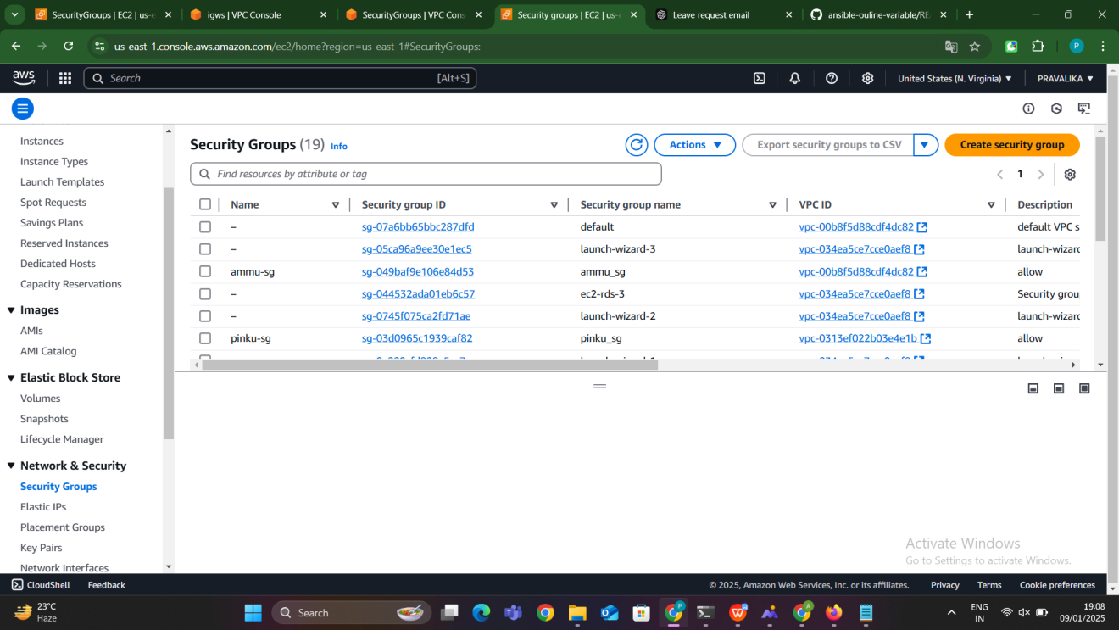

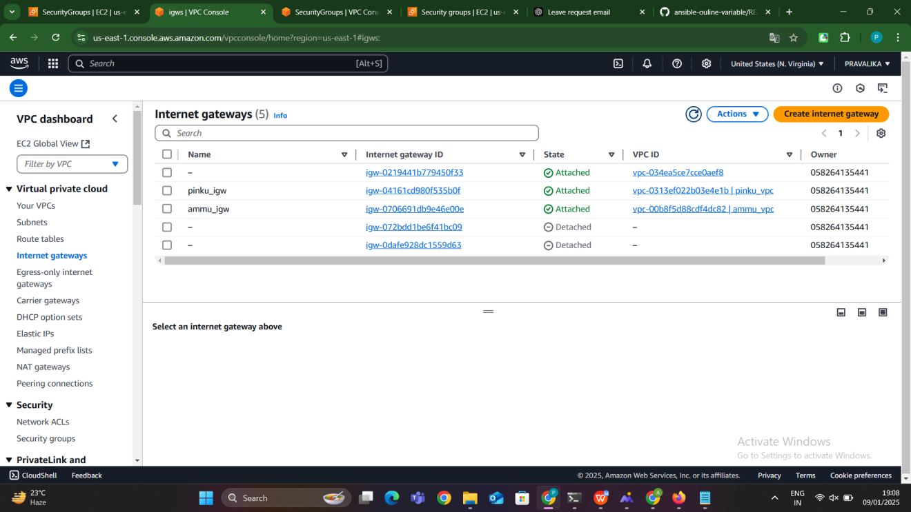

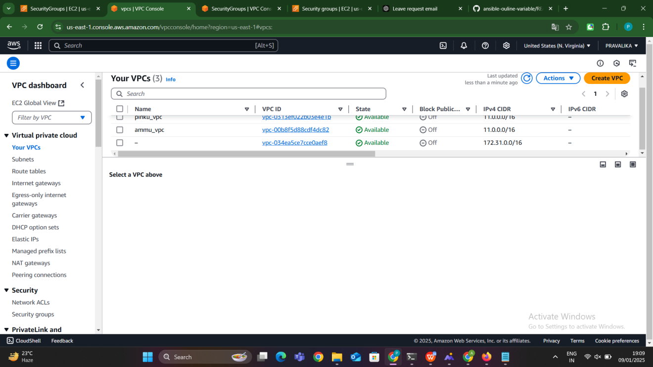

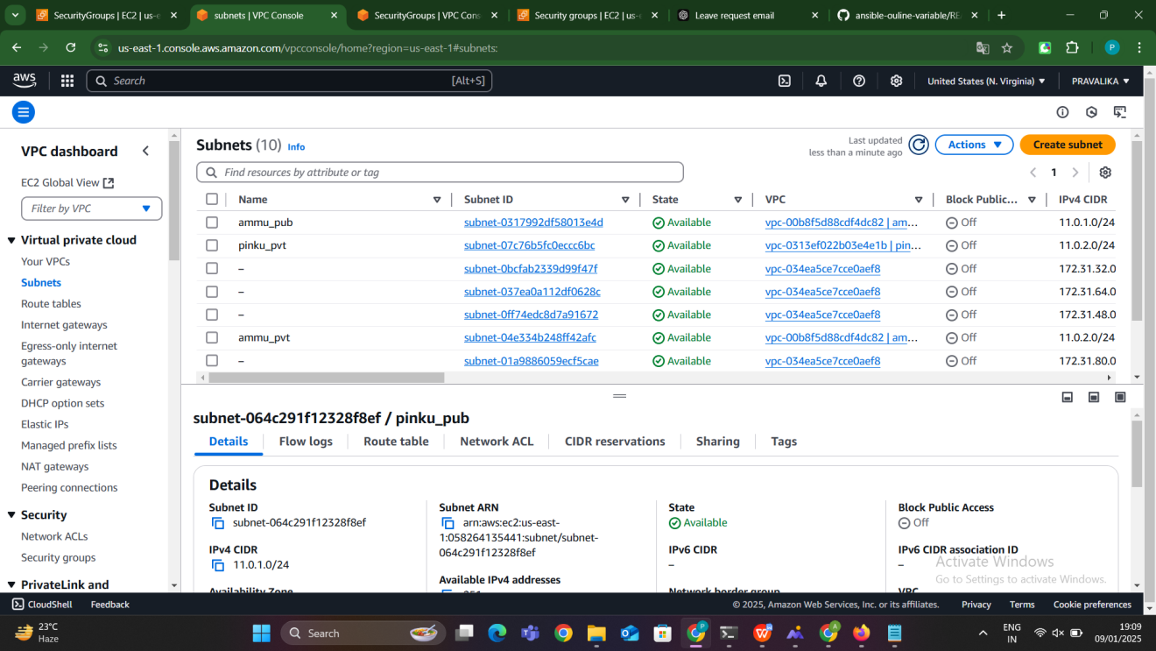

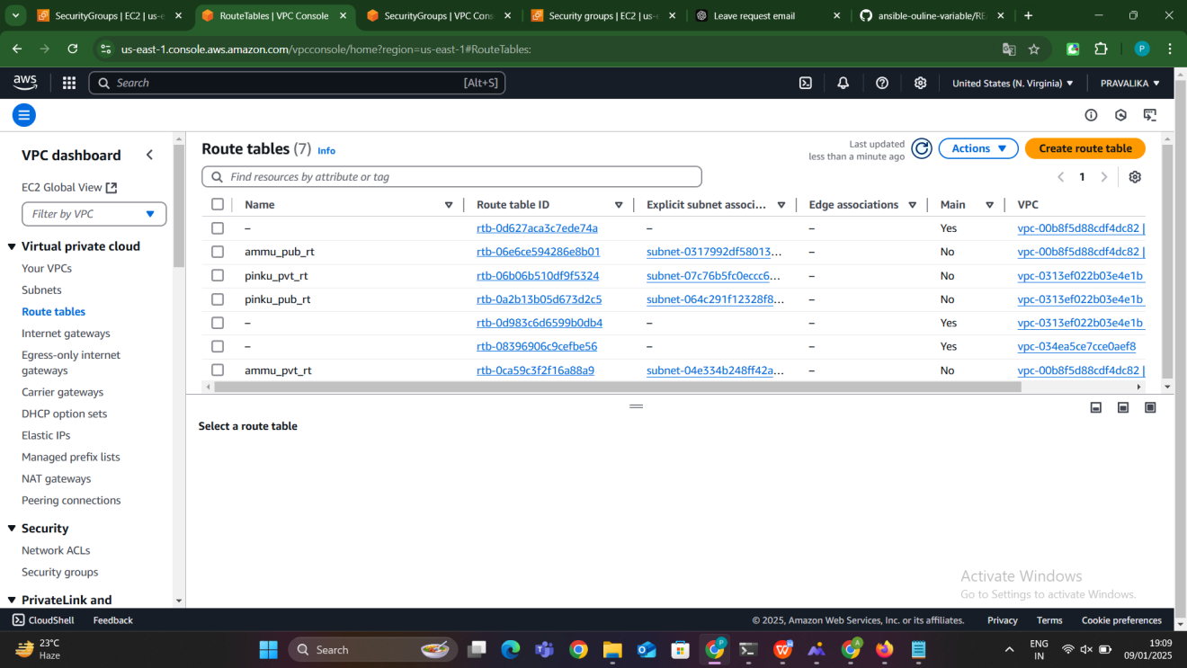

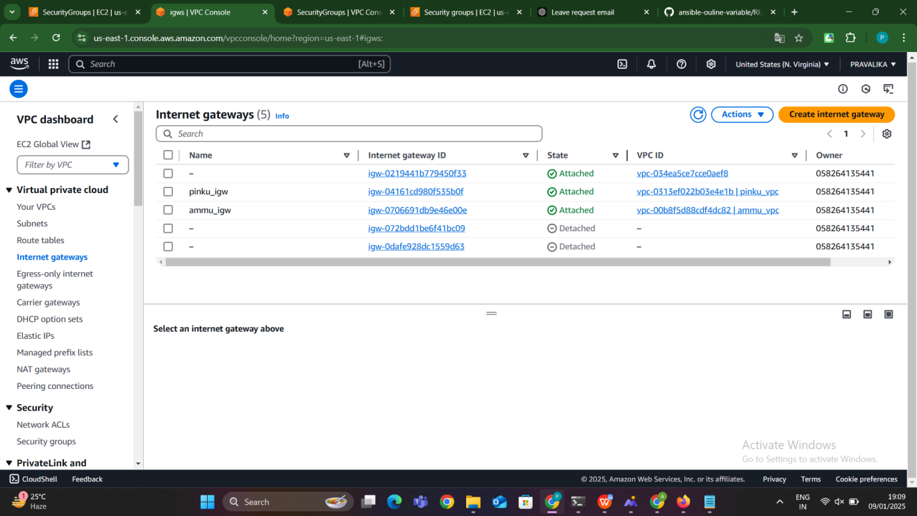

After creation we can able to deleted by giving state as absent then the resuorces what we have created will be deleted

